Foundations of Entrepreneurship
Question Bank – Solved Study Material
SY B.Tech • PCCOE Pune • AY 2026-27 • Summative exam (30 marks)

Unit 1 – Introduction to Entrepreneurship
Unit 2 – Entrepreneur Concept
Unit 3 – Business Organization and Business Laws
Unit 4 – Case Studies on Business Failures

How to use this material
Summative exam: 30 marks, 1 hr 15 min, 4 questions (one block per unit), all compulsory, with options inside Q3 and Q4. Questions carry 2, 4 or 5 marks.
Question | Parts | Marks
Q.1 (compulsory) | A: i), ii) B: i), ii) | 5 + 2
Q.2 (compulsory) | A and B | 4 + 4
Q.3 | A: any one of i)/ii) B: compulsory | 5 + 2
Q.4 | Any two of A, B, C | 4 + 4

How long should my answer be?
Marks | Write about | Must include
2 marks | 4–6 lines (≈50–70 words) | Definition + 2 key points or one example
4 marks | ≈ 1 page (≈120–160 words) | Definition, 4–5 points, a diagram or table if it fits
5 marks | 1–1.5 pages (≈160–220 words) | Intro, 5–6 points / steps, labelled diagram, example, short conclusion
6 marks | 1.5 pages (≈220–260 words) | Everything for 5 marks + comparison table or worked example

Exam tips: underline key words, draw neat labelled diagrams (they earn marks even when text is short), use point-wise answers, and end long answers with a one-line conclusion. The green "Remember" boxes give a short trick to recall each answer.

Contents
How to use this material 2
Contents 3
Unit 1: Introduction to Entrepreneurship 12
Q1. Explain the concept of entrepreneurship and discuss its significance in today's business environment. 12
Q2. Interpret the meaning of entrepreneurship by highlighting its essential characteristics. 12
Q3. Describe the concept of entrepreneurship and illustrate it with a suitable real-life example. 12
Q4. Discuss the role of opportunity identification in the concept of entrepreneurship. 13
Q5. Differentiate between an entrepreneur and a manager with suitable points. 13
Q6. Summarize the definitions of entrepreneurship given by various management thinkers and identify the common elements among them. 14
Q7. Classify the core elements of entrepreneurship and briefly explain each element. 14
Q8. Explain the evolution of entrepreneurship from ancient civilizations to the modern digital era. 14
Q9. Describe the major characteristics of entrepreneurship during the Ancient, Classical, Medieval, and Age of Exploration periods. 15
Q10. Summarize the significant changes in entrepreneurial activities brought about by the Four Industrial Revolutions. 15
Q11. Differentiate between entrepreneurship during the First Industrial Revolution and the Fourth Industrial Revolution based on technology, business models, and innovation. 15
Q12. Illustrate the evolution of entrepreneurship using a timeline from Ancient Civilization (3000 BC) to the Digital Age (2026), highlighting the major milestones. 16
Q13. Explain the role of entrepreneurship in employment generation with suitable real-life examples. 17
Q14. Discuss how entrepreneurship contributes to wealth creation and economic growth by citing appropriate examples. 17
Q15. Describe the contribution of entrepreneurship towards innovation and technological development with suitable examples. 18
Q16. Explain the significance of entrepreneurship in industrial and regional development with relevant business examples. 18
Q17. Discuss how entrepreneurship promotes exports and contributes to foreign exchange earnings with suitable examples. 18
Q18. Describe the contribution of entrepreneurship towards social development and improvement in the standard of living with relevant examples. 19
Q19. Explain how a high Need for Achievement (nAch) influences entrepreneurial success according to McClelland's Need Achievement Theory. 19
Q20. An entrepreneur consistently sets challenging goals, takes calculated risks, and seeks regular feedback to improve performance. Explain this entrepreneurial behaviour with reference to McClelland's Need Achievement Theory. 20
Q21. A startup founder successfully motivates employees by assigning leadership responsibilities, encouraging teamwork, and rewarding outstanding performance. Describe how the three needs proposed by McClelland can be identified in this scenario. 21
Q22. Two entrepreneurs exhibit different leadership styles. One enjoys solving challenging problems independently, while the other prefers leading large teams and influencing organizational decisions. Differentiate their dominant motivational needs using McClelland's Need Achievement Theory. 21
Q23. Discuss the importance of the three motivational needs proposed by McClelland in entrepreneurial development. 22
Q24. Explain why individuals with a high Need for Achievement (nAch) are more likely to become successful entrepreneurs than others. 22
Q25. Compare the entrepreneurial contributions of one entrepreneur from the Pre-Independence Era and one from the Post-Independence Era with reference to opportunity identification, innovation, and risk-taking. 23
Q26. Discuss the contributions of Indian entrepreneurs from the Pre-Independence and Post-Independence eras towards industrial and economic development. 24
Q27. Explain how the entrepreneurial journeys of Jamsetji Tata and Dhirubhai Ambani reflect the changing nature of entrepreneurship across different economic environments. 24
Q28. Describe the entrepreneurial lessons that can be learned from any two Indian entrepreneurs studied in this chapter. 25
Q29. Explain the role of entrepreneurship in economic development with reference to the contributions of one Pre-Independence and one Post-Independence Indian entrepreneur. 25
Q30. Compare the entrepreneurial philosophies of N. R. Narayana Murthy and Jamsetji Tata with respect to leadership, ethics, and business growth. 26
Quick Revision – Unit 1 26
Unit 2: Entrepreneur concept 28
Q1. Summarise any six reasons for becoming an entrepreneur, with a suitable example for each. 28
Q2. "Innovation is an engine of entrepreneurship." Examine the statement from the perspective of becoming an entrepreneur with a suitable example. 28
Q3. Interpret the term entrepreneur and list any two personal traits that support entrepreneurship. 28
Q4. A group of engineering graduates develops an affordable machine to solve a problem faced by small farmers. Illustrate what can motivate them to become entrepreneurs. 29
Q5. Classify the following roles as Entrepreneur, Businessman, or Manager: a person who starts a new venture, a person who operates an existing business for profit, and a person who manages employees and resources. 29
Q6. Differentiate between an entrepreneur and a businessman. 30
Q7. A student notices a business opportunity and decides to establish a new venture. As the venture grows, another person is appointed to plan and manage its day-to-day activities. Illustrate the roles of the two individuals and the business entity in this situation. 30
Q8. Compare - Enterprise, Entrepreneurship, Entrepreneur, Businessman, Manager on following points: Meaning; focus; nature, risk, time orientation, role, example. 30
Q9. Associate the below entrepreneurs according to the appropriate types. (Table: Karsanbhai Patel – Nirma; Ritesh Agarwal – OYO Rooms; Kiran Mazumdar-Shaw – Biocon; Verghese Kurien – Amul; Dhirubhai Ambani – Reliance Industries; Narayana Murthy – Infosys) 31
Q10. Present a contrast between different entrepreneurs based on the nature of business, ownership and size with suitable examples. 32
Q11. A social entrepreneur launches an affordable healthcare service for low-income communities. Analyze the possible challenges that the social entrepreneur may face in sustaining the venture. 32
Q12. Different entrepreneurial approaches are adopted to create social value, develop rural communities, and sustain family-owned businesses. Categorize the three types of entrepreneurs according to their primary focus and state one distinguishing feature of each. 33
Q13. A rural entrepreneur has limited access to finance and technology but possesses strong local knowledge, community support, and access to local resources. Analyze how these factors can influence the success of the venture. 33
Q14. A family-owned enterprise aims to expand its business while preserving family involvement and ensuring continuity across generations. Analyze the key factors that make this approach different from social and rural entrepreneurship. 34
Q15. A rural entrepreneur has limited access to finance and technology but possesses strong local knowledge, community support, and access to local resources. Analyze how these factors can influence the success of the venture. 34
Q16. Break down various push and pull factors to become an entrepreneur. 34
Q17. A student develops a low-cost agricultural device after observing difficulties faced by farmers. The student identifies a market opportunity and begins planning a venture. Outline the stages of the entrepreneurial decision process represented in this situation. 36
Q18. Lijjat Papad was started by seven women in 1959 with a small-scale production activity and gradually expanded into a large cooperative enterprise. Imagine you are part of the founding team just before the first product is taken to the market. Outline the key activities that must be completed to launch the enterprise successfully. 36
Q19. Nithin Kamath identified high brokerage fees as a problem and developed a discount-brokerage model before launching Zerodha. Break down the major stages of the entrepreneurial decision process reflected in this example. 37
Q20. Zomato began as a platform for accessing restaurant information and later expanded into food delivery and other services. Analyze the major resources that would be required to transform such a platform into a scalable business. 37
Q21. In 1981, seven engineers came together with a shared vision to establish Infosys. With limited initial capital, they began with software projects and gradually built customer trust and expanded into a global IT company. Illustrate the role of business planning and resource mobilization in this entrepreneurial journey. 38
Q22. A student notices that many commuters in his locality spend considerable time waiting for public transport. He considers developing a service to address the problem. Illustrate the steps the student should follow to convert this observation into an entrepreneurial opportunity. 39
Q23. An engineering student wants to start a venture but has not yet decided what business to pursue. During a visit to a local industrial area, the student observes several recurring problems faced by workers and customers. Illustrate a systematic approach the student can use to identify a suitable entrepreneurial opportunity. 40
Q24. Flipkart began as an online platform for selling books and later expanded into a large e-commerce marketplace. Analyze the entrepreneurial opportunity that enabled the venture to expand beyond its initial business model. 40
Q25. Two entrepreneurs identify the problem of low agricultural productivity. The first develops smart farming equipment, while the second develops a digital platform connecting farmers with agricultural experts and markets. Analyze how the entrepreneurial opportunities of the two ventures differ despite addressing the same broad problem. 41
Q26. Aravind Eye Care System developed a model for providing affordable eye-care services to a large number of patients, including people from economically weaker sections. Analyze the entrepreneurial approach adopted by Aravind Eye Care to create both social and economic value. 41
Q27. A city faces increasing waste generation and rising costs of waste management. An engineering startup proposes a business that collects segregated waste, processes recyclable material and converts organic waste into useful products. Outline the entrepreneurial potential of the proposed venture from the perspective of sustainability and value creation. 42
Q28. A city faces increasing problems related to waste generation, air pollution, and inefficient resource use. An engineering startup wants to develop a business solution addressing these problems. Examine a suitable entrepreneurial sector and a possible value-creating solution. 42
Q29. SELCO India developed decentralized solar-energy solutions for communities that had limited access to reliable energy. Outline how the venture demonstrates the possibility of combining innovation, social impact and business sustainability. 43
Q30. DeHaat uses technology to provide farmers with agricultural inputs, advisory services and market linkages. Compare the value created by DeHaat with that of a conventional agricultural-input business. 44
Quick Revision – Unit 2 44
Unit 3: Business Organization and Business Laws 46
Q1. Two friends decide to start a consulting firm by contributing capital, sharing responsibilities and agreeing to share profits. Interpret the form of business organization suitable for this arrangement along with its basic features. 46
Q2. Consider the following: McDonald's franchise outlets, Haldiram's franchise outlets, Infosys, Subway franchise outlets. Select the business that does not represent the same business arrangement as the other three and explain the basis for your selection. 46
Q3. Relate each of the following real-life business examples with the most appropriate type of business. (D-Mart; McDonald's India; Amul; Haldiram's; a local shop owned by a single individual; a law firm of two or more professionals sharing profits; a professional services firm registered as an LLP; Tata Group companies with formal boards, independent directors, disclosures and accountability mechanisms) 47
Q4. Compare Partnership and Limited Liability Partnership (LLP) with respect to ownership, liability and management. 47
Q5. A restaurant owner operates an independent restaurant, while another entrepreneur operates an outlet using the brand name, standard processes and support of an established restaurant chain. Contrast the two business arrangements. 48
Q6. A well-known restaurant brand allows an independent entrepreneur to use its brand name, products, operating procedures and marketing system in return for agreed payments. Interpret the business arrangement and examine the relationship between the two parties. 48
Q7. Amul and Mother Dairy both operate in the dairy sector but have different organizational backgrounds and structures. Summarize the organizational characteristics that distinguish the two businesses. 49
Q8. Dabur India Limited has a long history as a family-founded business but operates today as a professionally managed listed company with a formal corporate structure. Relate its present organizational structure with the characteristics of a Joint Hindu Family Business. 50
Q9. Haldiram's has expanded through a combination of company-operated businesses and franchise arrangements. Break down the role of the brand owner and franchise operator in such an arrangement. 50
Q10. A student makes the following observations about Infosys: It has a formal Board of Directors. Responsibilities are assigned through a structured governance system. Information is disclosed to stakeholders. Major decisions are subject to accountability mechanisms. One of the following interpretations is incorrect: A. These practices are associated with corporate governance. B. These practices support transparency and accountability. C. These practices indicate that Infosys is a sole proprietorship. D. These practices protect stakeholder interests. Select the incorrect interpretation and explain the correction. 52
Q11. A group of engineering graduates wants to establish a new company in India. Arrange the following activities in a logical sequence for starting the business: Obtain required registrations and licences; Develop the business idea; Select the appropriate form of business; Register the business; Comply with applicable tax and labour requirements. 53
Q12. Business: RSM India; Structure: LLP; Activity: Professional services; Partners: Multiple; Liability: Limited according to LLP framework. Interpret the information and associate the business structure with the appropriate Indian legislation. 53
Q13. Three engineering graduates decide to establish a healthcare startup. They have selected their business structure and arranged initial finance, but they have not yet completed the formal registration or obtained the applicable permissions. Interpret the situation and outline the legal steps that should be addressed before commencing business operations. 53
Q14. A neighbourhood kirana business is operated and controlled by a single proprietor, while Flipkart Private Limited was incorporated as a private limited company. Examine the legal formalities involved in establishing these two forms of business in India. 54
Q15. During an FDA inspection on 19 August 2026, the Bombay Presidency Radio Club recorded a 47% non-compliance rate, following which its food business licence was suspended and it was ordered to stop the purchase, sale and distribution of food during the suspension period. Relate the importance of obtaining and maintaining the required licences while operating a food business. 55
Q16. Relate the following Indian enterprises with the legal requirement most directly relevant to the stated activity: (Amul – food processing; RSM India – LLP structure; Tata International – import/export; Infosys – corporate structure; Tata Steel – manufacturing; Sun Pharma – pharmaceutical manufacturing; Flipkart – e-commerce; Mother Dairy – dairy products) 56
Q17. The Maharashtra FDA and Pune Rural Police recently busted an inter-district synthetic milk racket, with raids conducted at locations including Manchar, Akluj, Ahilyanagar, Sillod and Sangli. Thirteen people were arrested and materials worth more than ₹2 crore were seized. Analyse the legal and business-compliance failures represented in this case and explain the risks they create for a food entrepreneur. 56
Q18. Consider Tata Motors and Tata International. Both are part of the Tata business group, but their activities involve different operational requirements. Contrast the additional legal considerations that may arise for an automobile manufacturer and an enterprise engaged in international trade. 57
Q19. A software startup initially operates as a small LLP providing domestic services. It later begins importing computer hardware and expands its workforce substantially. Explain how the legal requirements applicable to the enterprise may change as its activities expand. 58
Q20. In June 2026, an environmental regulator accused a Tata Electronics facility in Hosur of groundwater contamination linked to wastewater discharge. Tata stated that an independent analysis found the facility compliant. Interpret the case from the perspective of an entrepreneur planning to establish a manufacturing facility and explain the importance of environmental compliance before and during business operations. 58
Q21. Amul has built strong recognition around its brand name, logo and distinctive identity. Explain why protecting such brand elements is important for an established business. 59
Q22. Business A: A manufacturer sells goods directly to customers. Business B: An online marketplace facilitates sales between sellers and customers. Contrast the GST-related business considerations that may arise in the two situations. 60
Q23. Relate each of the following real-life examples with the appropriate IPR category: (Tata Motors' "TATA" brand name and logo; a patented technological invention developed by CSIR laboratories; the original source code of an Indian software product such as Zoho's software; Darjeeling Tea's protected identity based on its geographical origin; the distinctive "Amul" name and logo used on dairy products; a newly developed drug formulation by an Indian pharmaceutical company; the distinctive design of a commercially manufactured product registered by its creator; Banarasi Saree, whose identity is linked to its traditional geographical region) 60
Q24. "My company has registered its trademark, so competitors cannot copy my newly developed machine." Restate the statement correctly by distinguishing protection of a brand from protection of an invention. 61
Q25. A pharmaceutical company develops a new drug → ______; It gives the medicine a distinctive brand name → ______; It employs workers in its manufacturing facility → ______; It sells the medicine subject to applicable indirect-tax requirements → ______. Relate the legal framework associated with each activity. 61
Q26. A company owns a patent, a trademark and copyrighted software. Differentiate the three assets based on the nature of what each form of IPR protects. 62
Q27. A Pune-based engineering startup develops a unique braking mechanism and sells it under the brand name "Safestop." Interpret the two different intellectual-property aspects represented by the invention and the brand name. 63
Q28. In February 2026, a tax investigation into the restaurant sector reported alleged manipulation of billing software to suppress sales, including instances where recorded bills were allegedly reduced substantially. Outline the legal responsibility of a business regarding sales records and tax compliance in light of the above case. 63
Q29. On 18 August 2026, Mumbai Police raided a garment manufacturing unit at Charkop Industrial Estate and rescued 13 boys aged 13–16 who were allegedly being employed as child labourers. Analyse the legal responsibility of a business owner while recruiting workers for a manufacturing enterprise. 64
Q30. On 12 July 2026, a raid on factories in Ludhiana resulted in the rescue of 19 minors allegedly employed as workers. Cases were registered against the factory owners under child-labour and juvenile-justice provisions. A business may be legally established as an enterprise but still violate laws through its employment practices. Break down this distinction using the July 2026 Ludhiana case. 65
Quick Revision – Unit 3 65
Unit 4: Case Studies on Business Failures 67
Q1. A startup develops an innovative product, but very few customers are willing to purchase it. Use the concept of entrepreneurial failure to determine the issue represented by this situation. 67
Q2. An engineering startup has developed a technically successful product, but its production cost is much higher than the price customers are willing to pay. Apply the concept of entrepreneurial failure to demonstrate why technical success alone may not ensure business success. 67
Q3. PepperTap, an Indian grocery-delivery startup, shut down its operations in April 2016. Consider the following issues: A. Difficulty in achieving sustainable unit economics; B. Lack of product innovation; C. Intellectual-property infringement; D. Workplace safety. Apply the concept of entrepreneurial failure and select the issue most relevant to a hyperlocal delivery business such as PepperTap. 67
Q4. Kingfisher Airlines ceased operations in October 2012 after prolonged financial and operational difficulties. Show one warning sign in this situation that an entrepreneur should recognize before a venture reaches the failure stage. 68
Q5. Jet Airways suspended operations in April 2019 amid severe financial difficulties. A new airline is planning to operate with heavy debt and high fixed costs. Illustrate one lesson from the Jet Airways experience that should be considered before launching the venture. 68
Q6. Nokia lost significant smartphone market share during the early 2010s as the industry shifted rapidly toward smartphones and competing operating systems. A mobile-device startup is facing a similar technological shift. Modify its strategy to remain competitive. 69
Q7. Byju's experienced severe financial and governance difficulties following a period of rapid expansion and acquisitions. Apply the concept of entrepreneurial failure and modify one strategic decision that could have helped a rapidly expanding startup maintain greater financial sustainability. 69
Q8. The following enterprises faced significant business difficulties or failure at different stages of their operations: Kingfisher Airlines, Jet Airways, Nokia Mobile Phones, Kodak, Byju's, WeWork. For any three enterprises from the above list examine the major reason(s) that contributed to their business failure or decline. 70
Q9. Blockbuster's traditional video-rental model was disrupted by new forms of movie distribution, particularly streaming. A new entertainment startup is experiencing declining demand because customers are shifting rapidly toward a digital alternative. Determine and justify the most appropriate entrepreneurial response from the following: A. Continue the existing model without modification; B. Increase investment only in physical outlets; C. Modify the business model according to changing customer behaviour; D. Reduce customer access to digital services. 70
Q10. Kingfisher Airlines faced multiple challenges before ceasing operations. Identify the three most relevant reasons from the following and examine them according to their significance in the case: Financial difficulties, Brand positioning, High debt burden, Operational difficulties, Product packaging. 71
Q11. Use the following failure-reason cards to classify the enterprises: Financial mismanagement; Technological disruption; Rapid expansion; Changing customer behaviour; Governance issues. 71
Q12. A new venture plans to enter a market dominated by rapidly changing technology. Based on the experience of Nokia, examine the component of the business plan that should receive particular attention and explain its relevance. 72
Q13. Jet Airways, Stayzilla, Cafe Coffee Day, Reliance Communications, DHFL, Videocon Industries, Future Retail, Subhiksha. For each selected business, examine one "red flag" that a new entrepreneur should monitor in a similar venture. 73
Q14. Entrepreneur A has rapidly increasing sales and a growing customer base, but relies heavily on borrowed funds and operates with very low profit margins. Entrepreneur B has moderate sales growth and healthy profit margins, but is losing customers to a new technology introduced by competitors. Predict which entrepreneur is facing the more immediate risk of business failure and illustrate your choice using a suitable real-life business failure case. 73
Q15. A food-delivery startup reports the following: customer numbers are increasing, delivery costs are rising, discounts are increasing, cash losses are growing, competitors are offering lower delivery charges. Determine the two most significant reasons that could lead this venture toward failure and suggest one modification to its business strategy. 74
Q16. A new café chain plans rapid expansion after receiving investment. Illustrate one precaution from the Café Coffee Day experience that should be incorporated before opening multiple outlets. 75
Q17. An engineering startup has limited funds and is considering spending most of its capital on office infrastructure before acquiring its first customers. Explain one alternative use of resources that would help reduce the risk of early-stage business failure. 75
Q18. An entrepreneur has limited funds and is planning to launch a new product. The following activities are proposed: A. Large office setup; B. Customer validation; C. Market assessment; D. Large-scale production. Arrange the activities in an appropriate sequence for reducing the risk of early business failure. 75
Q19. Associate each entrepreneurial risk with the most appropriate preventive measure: Excessive borrowing; Uncertain customer demand; Rapid technological change; Dependence on one supplier. 76
Q20. A startup has received ₹50 lakh in funding. It has only 500 paying customers and has not yet established a sustainable revenue model. The founder proposes: A. Expand to five cities; B. Increase office infrastructure; C. Validate the business model and strengthen customer acquisition; D. Launch three additional products. Select the most appropriate decision and illustrate the reason. 76
Q21. Byju's underwent rapid expansion before facing significant financial and governance difficulties. A new ed-tech entrepreneur plans a similar expansion strategy. Show any three checks that should be completed before implementing the expansion. 77
Q22. An entrepreneur has ₹10 lakh available for a new venture. The proposed allocation is: ₹7 lakh – office/interior setup; ₹1 lakh – market research; ₹1 lakh – product testing; ₹1 lakh – working capital. Determine the allocation that creates the greatest risk to the venture and modify the allocation principle to improve business sustainability. 77
Q23. A startup has: strong customer demand, limited cash reserves, increasing production costs, dependence on a single supplier, plans for rapid expansion. Model a three-point action plan that addresses the major risks before the entrepreneur proceeds with expansion. 78
Q24. Kingfisher Airlines and Nokia experienced very different forms of business decline. Kingfisher faced serious financial and operational difficulties. Nokia struggled during major changes in the mobile-phone industry. Associate each case with one precaution that would be particularly relevant to a new entrepreneur entering the respective industry. 79
Q25. A startup similar to Stayzilla is experiencing falling revenue. Model a three-step decision path beginning with: Falling revenue → ______ → ______ → ______. The final step should represent the entrepreneur's decision after examining the situation. 79
Q26. Compare the following: Kodak – major technological/market transition; Kingfisher Airlines – financial and operational difficulties. Complete the table (Case | Dominant risk | Preventive focus). 80
Q27. Quibi launched in April 2020 and shut down roughly six months later. Product development → __________ → Market launch → Customer response → Business decision. Determine the entrepreneurial activity that should occur between product development and large-scale launch. 80
Q28. About Satyam Computer Services, a student writes: "The Satyam case mainly demonstrates the importance of increasing advertising expenditure during rapid business growth." Identify the conceptual error and modify it with the appropriate entrepreneurial lesson. 81
Q29. A startup has experienced the following sequence: Rapid expansion → increasing expenditure → cash-flow pressure → delayed payments → loss of stakeholder confidence. Illustrate a real failed business case that demonstrates a similar pattern and construct two points in the entrepreneur's earlier decision-making where corrective action could have been introduced. 82
Q30. Consider the following cases: Kodak – difficulty adapting to digital photography; Kingfisher Airlines – severe financial difficulties; Nokia – challenges responding to technological and market changes. Model one common pre-launch checklist containing three checks that an entrepreneur can use to reduce the risk of experiencing similar failure conditions. 83
Quick Revision – Unit 4 83

Unit 1: Introduction to Entrepreneurship

Topic 1: Meaning, Definition, Concept (Easy)

Q1. Explain the concept of entrepreneurship and discuss its significance in today's business environment.
3 Marks • L2 Understand • Easy • CO1
Entrepreneurship is the process of spotting an opportunity, bringing together resources and taking risk to start a new venture that creates value (and profit). The person who does this is the entrepreneur.
Significance today:
1. Jobs – startups and MSMEs create employment, not just seek it.
2. Innovation – new products and digital services (e.g. UPI apps, ed-tech, EVs).
3. Economic growth – adds to GDP, exports and tax revenue.
4. Solving problems – healthcare, farming, clean energy, waste.
5. Self-reliance – supports Startup India and Make in India goals.
Example: Zerodha made share trading cheap for millions of small investors.
Remember: Entrepreneurship = Opportunity + Risk + Resources → Value.

Q2. Interpret the meaning of entrepreneurship by highlighting its essential characteristics.
3 Marks • L2 Understand • Easy • CO1
Meaning: Entrepreneurship is the ability and willingness to start, organise and manage a new business while bearing its risks, in order to earn profit and create value.
Essential characteristics:
1. Innovation – doing something new or in a new way.
2. Risk-bearing – money, time and reputation are at stake.
3. Opportunity orientation – sees gaps others miss.
4. Organising resources – combines land, labour, capital and technology.
5. Value creation – useful product for customers, profit for owner.
6. Goal-directed and continuous – a process, not a one-time act.
Remember: Characteristics = "I R O O V G" – Innovation, Risk, Opportunity, Organising, Value, Goal.

Q3. Describe the concept of entrepreneurship and illustrate it with a suitable real-life example.
3 Marks • L2 Understand • Easy • CO1
Concept: Entrepreneurship is a process in which a person identifies a need, turns it into a business idea, gathers resources, takes risk and builds an enterprise that creates value.
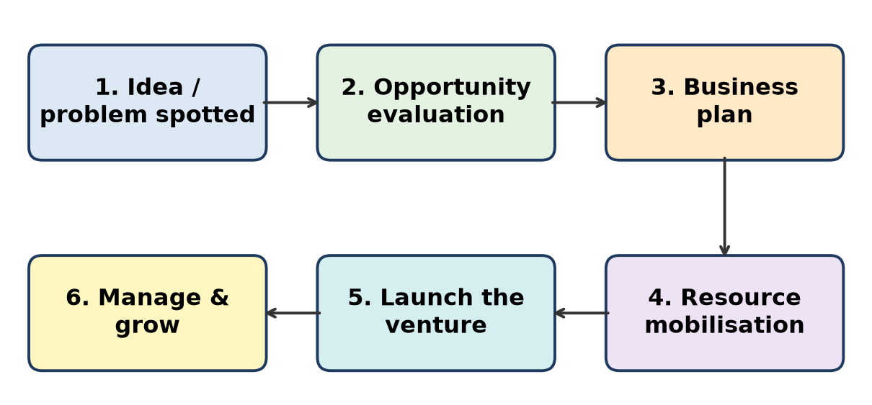
Figure: Entrepreneurial process
Example – Lijjat Papad (1959): Seven women in Mumbai borrowed ₹80 and began making papad on a terrace.
- Opportunity: steady demand for home-style papad; women wanted income.
- Resources & risk: small loan, their own labour.
- Value: today a large women-owned cooperative giving livelihood to thousands of women.
Remember: Need → Idea → Risk → Venture → Value.

Q4. Discuss the role of opportunity identification in the concept of entrepreneurship.
3 Marks • L2 Understand • Easy • CO1
Opportunity identification means spotting an unmet need, problem or market gap that can be served profitably. It is the first and most important step of entrepreneurship.
Role:
1. Starting point – no opportunity, no venture.
2. Direction – decides product, customer and market.
3. Reduces risk – a real need means real buyers.
4. Source of innovation – problems lead to new solutions.
5. Competitive edge – early movers gain market share.
Example: Nithin Kamath saw that brokerage fees were too high and launched Zerodha, a discount broker.
Remember: No problem spotted = no business started.

Q5. Differentiate between an entrepreneur and a manager with suitable points.
3 Marks • L2 Understand • Easy • CO1
Point | Entrepreneur | Manager
Role | Starts a new venture | Runs an existing organisation
Risk | Bears business risk | Bears no ownership risk
Reward | Profit (uncertain) | Fixed salary
Status | Owner | Employee
Focus | Innovation and opportunity | Efficiency and control
Example | Ritesh Agarwal (OYO founder) | A store manager at D-Mart

Conclusion: An entrepreneur creates and risks; a manager executes and controls.
Remember: Entrepreneur = owner + risk + profit; Manager = employee + salary.

Q6. Summarize the definitions of entrepreneurship given by various management thinkers and identify the common elements among them.
3 Marks • L2 Understand • Easy • CO1
Definitions:
1. Richard Cantillon – entrepreneur buys at a known price and sells at an uncertain price, so he bears risk.
2. J. A. Schumpeter – entrepreneur is an innovator who carries out "new combinations" (new product, method, market, source or organisation).
3. Peter Drucker – entrepreneur searches for change, responds to it and exploits it as an opportunity.
4. Hisrich & Peters – process of creating something new with value, devoting time and effort, assuming risks and receiving rewards.
Common elements: risk-taking, innovation, opportunity, value creation and reward.
Remember: Cantillon = Risk, Schumpeter = Innovation, Drucker = Change/Opportunity.

Q7. Classify the core elements of entrepreneurship and briefly explain each element.
3 Marks • L2 Understand • Easy • CO1
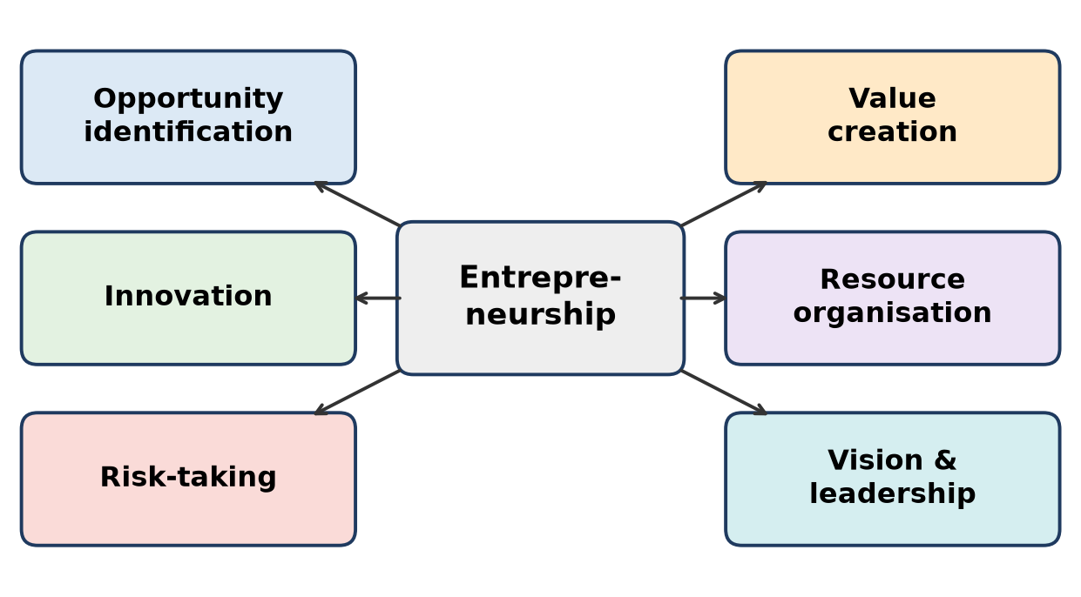
Figure: Core elements of entrepreneurship
1. Opportunity identification – finding an unmet need.
2. Innovation – new product, process or business model.
3. Risk-taking – accepting uncertainty of loss.
4. Resource organisation – arranging money, people, machines.
5. Vision & leadership – clear goal and guiding the team.
6. Value creation – benefit for customers, profit for owner, growth for society.
Remember: "O-I-R-R-V-V": Opportunity, Innovation, Risk, Resources, Vision, Value.

Topic 2: Evolution of Entrepreneurship (Easy)

Q8. Explain the evolution of entrepreneurship from ancient civilizations to the modern digital era.
3 Marks • L2 Understand • Easy • CO1
Entrepreneurship has grown from simple trade to global digital startups.
1. Ancient (from about 3000 BC) – barter and trade by Indus Valley and Mesopotamian merchants.
2. Classical – coins, organised markets, long-distance trade (Silk Road).
3. Medieval – craft guilds, merchant families, travelling traders like Marco Polo.
4. Age of Exploration – sea routes, joint-stock companies (East India Company, 1600).
5. Industrial Revolutions – factories, mass production, then computers.
6. Digital era – internet, apps, AI, platforms and startups (e.g. Flipkart, Zomato).
The meaning also changed: from trader/risk-bearer (Cantillon) to innovator (Schumpeter).
Remember: Barter → Coins → Guilds → Ships → Factories → Apps.

Q9. Describe the major characteristics of entrepreneurship during the Ancient, Classical, Medieval, and Age of Exploration periods.
3 Marks • L2 Understand • Easy • CO1
Period | Key characteristics
Ancient (from about 3000 BC) | Barter, local trade, farming surplus, early merchants of Indus Valley and Mesopotamia
Classical (about 500 BC – 500 AD) | Coins and money, organised markets, Greek and Roman traders, Silk Road trade
Medieval (about 500 – 1500) | Craft guilds controlled quality and prices, merchant families, travelling traders (Marco Polo)
Age of Exploration (about 1500 – 1700) | Sea voyages, colonial trade, joint-stock companies sharing risk (East India Company 1600)

Trend: trade grew from local to global, and risk began to be shared among investors.
Remember: Ancient = barter, Classical = coins, Medieval = guilds, Exploration = ships and shares.

Q10. Summarize the significant changes in entrepreneurial activities brought about by the Four Industrial Revolutions.
3 Marks • L2 Understand • Easy • CO1
Revolution | Key technology | Change in entrepreneurship
1st (from about 1760) | Steam engine, mechanised textile mills | Workshops became factories; factory owners emerged
2nd (from about 1870) | Electricity, steel, assembly line | Mass production, large corporations (e.g. Ford, Tata Steel)
3rd (from about 1969) | Computers, electronics, internet | IT and software firms (Infosys), automation, global outsourcing
4th (from about 2011) | AI, IoT, robotics, cloud, big data | Tech startups, digital platforms, smart factories

Overall, entrepreneurship moved from muscle power to machine power to brain power.
Remember: 1 = Steam, 2 = Electricity, 3 = Computers, 4 = AI/IoT.

Q11. Differentiate between entrepreneurship during the First Industrial Revolution and the Fourth Industrial Revolution based on technology, business models, and innovation.
3 Marks • L2 Understand • Easy • CO1
Basis | First Industrial Revolution | Fourth Industrial Revolution
Period | From about 1760 | From about 2011
Technology | Steam power, mechanised looms | AI, IoT, robotics, cloud, data
Business model | Factory-based mass manufacturing, owner-managed | Platforms, subscriptions, sharing and app-based models
Innovation | Slow, mechanical, mostly in machines | Very fast, digital, in products and business models
Capital need | Large investment in plant | Can start small and scale online
Example | Textile mills | Zomato, Ola, Zerodha

Conclusion: 1st IR built factories; 4th IR builds digital platforms.
Remember: Then: steam and spindles; now: data and devices.

Q12. Illustrate the evolution of entrepreneurship using a timeline from Ancient Civilization (3000 BC) to the Digital Age (2026), highlighting the major milestones.
3 Marks • L2 Understand • Easy • CO1
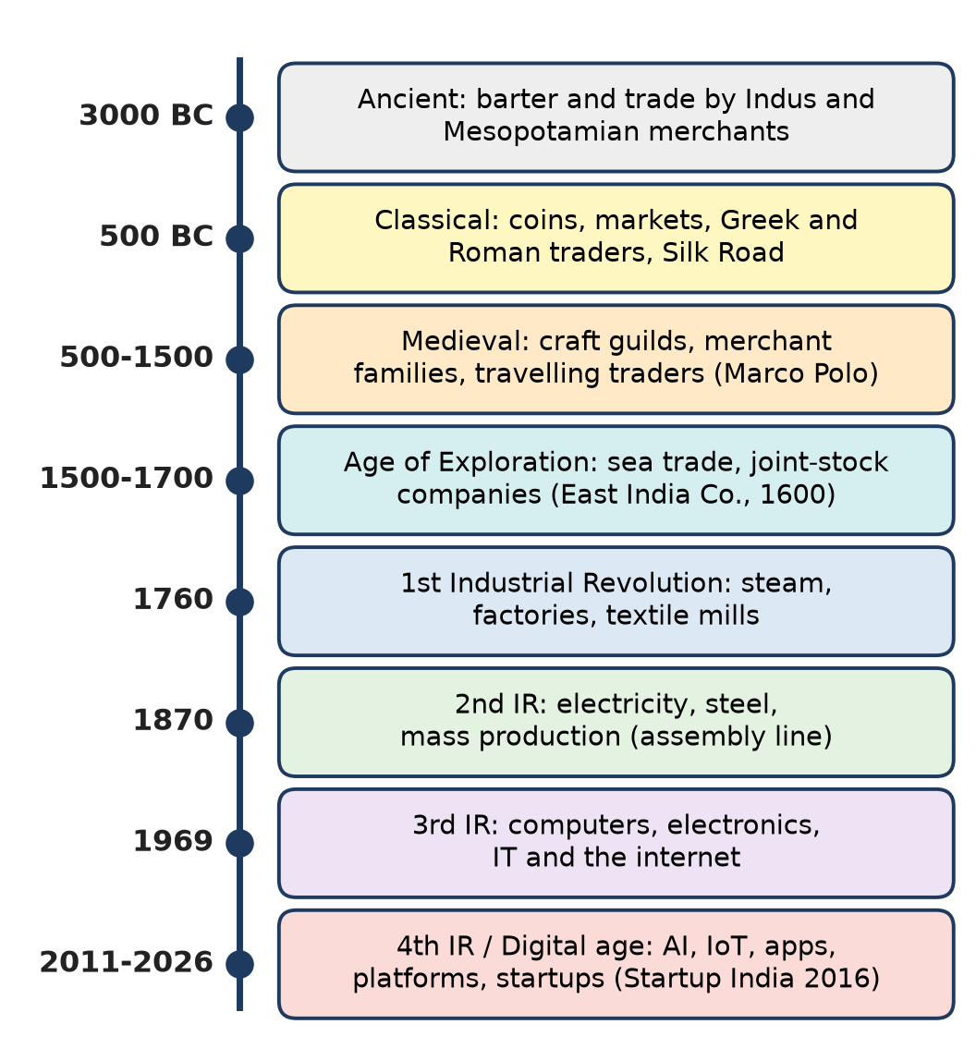
Figure: Timeline of entrepreneurship
Key milestones:
- 3000 BC – barter and trade begin.
- 1600 – East India Company: early joint-stock company.
- 1760 / 1870 / 1969 – 1st, 2nd and 3rd Industrial Revolutions.
- 2011 onwards – Industry 4.0; Startup India (2016) boosts Indian startups; by 2026 AI-based startups grow fast.
Remember: Remember 4 jumps: 3000 BC trade, 1600 company, 1760 factory, 2011 digital.

Topic 3: Role of Entrepreneurship in Economic Development (Moderate)

Q13. Explain the role of entrepreneurship in employment generation with suitable real-life examples.
4 Marks • L2 Understand • Moderate • CO1
Entrepreneurs are job creators, not job seekers. Each new venture creates direct and indirect jobs.
1. Self-employment – the entrepreneur employs himself first.
2. Direct jobs – hiring workers, engineers, sales staff. Example: Infosys, started by seven founders in 1981, now employs over three lakh people.
3. Indirect jobs – suppliers, transporters, dealers. Example: food-delivery platforms like Zomato and Swiggy give work to lakhs of delivery partners.
4. MSMEs – the MSME sector employs about 11 crore people, the largest after agriculture.
5. Rural and women employment – Amul links lakhs of milk farmers; Lijjat Papad gives income to thousands of women.
6. Reduces disguised unemployment – moves surplus farm labour into industry and services.
Government support: Startup India, PMEGP, Mudra loans encourage people to start businesses that hire others.
Remember: One entrepreneur → many jobs (direct + indirect + supplier jobs).

Q14. Discuss how entrepreneurship contributes to wealth creation and economic growth by citing appropriate examples.
4 Marks • L2 Understand • Moderate • CO1
Entrepreneurs combine idle resources into productive enterprises, which creates wealth and raises GDP.
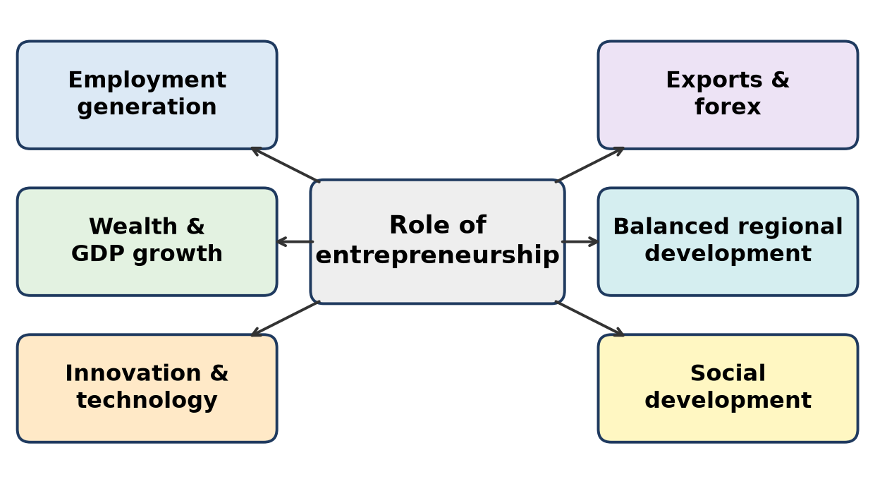
Figure: Role of entrepreneurship in economic development
1. Capital formation – mobilise savings into business; Dhirubhai Ambani brought lakhs of small investors into the share market through Reliance's 1977 public issue.
2. Increase in GDP and per-capita income – more goods and services are produced.
3. Wealth sharing – ESOPs made many Infosys employees wealthy.
4. Government revenue – GST and income tax fund roads, schools and hospitals.
5. Multiplier effect – one big plant (e.g. a steel or auto plant) creates many small ancillary units.
6. Better use of resources – idle land, labour and local raw material are used.
Remember: Entrepreneur turns idle savings into running factories → GDP up.

Q15. Describe the contribution of entrepreneurship towards innovation and technological development with suitable examples.
4-5 Marks • L2 Understand • Moderate • CO1
Schumpeter called the entrepreneur an innovator who brings "new combinations" to the market.
1. New products – Bharat Biotech developed the indigenous COVID-19 vaccine Covaxin.
2. New processes – Aravind Eye Care's assembly-line style surgery lowered cost per operation.
3. New business models – Zerodha's flat-fee discount broking; Flipkart's cash-on-delivery.
4. Technology adoption – startups use AI, IoT and cloud and take them to small businesses and villages.
5. Indigenous technology – Skyroot Aerospace launched Vikram-S (2022), India's first privately built rocket.
6. Research and patents – firms invest in R&D, file patents and partner with IITs and incubators.
7. Spill-over – competitors copy and improve, so the whole industry upgrades.
Government support: Atal Innovation Mission, incubators, Startup India tax benefits.
Remember: Entrepreneur = bridge between invention (lab) and innovation (market).

Q16. Explain the significance of entrepreneurship in industrial and regional development with relevant business examples.
4-5 Marks • L2 Understand • Moderate • CO1
Entrepreneurship spreads industry beyond big cities and reduces regional imbalance.
1. Growth of industrial towns – Tata Steel turned Sakchi village into the industrial city of Jamshedpur.
2. Industrial clusters – Pimpri-Chinchwad and Chakan (Pune) grew around Tata Motors and Bajaj Auto, with hundreds of small suppliers.
3. Rural development – Amul made Anand (Gujarat) a dairy hub and raised farmers' income.
4. Infrastructure – roads, power, housing, schools and hospitals come up around industries.
5. Ancillary units – large firms create demand for small units (castings, packaging, transport).
6. Use of local resources – agro-processing, handicrafts and tourism use local raw material and skills.
7. Reduces migration – jobs near home keep people in villages and small towns.
Government support: MIDC estates, incentives for backward areas, Make in India and PLI schemes.
Remember: Industry follows entrepreneurs; towns follow industry (Jamshedpur, Anand, Chakan).

Q17. Discuss how entrepreneurship promotes exports and contributes to foreign exchange earnings with suitable examples.
4 Marks • L2 Understand • Moderate • CO1
Entrepreneurs sell Indian goods and services abroad and earn foreign exchange (forex), which pays for imports like crude oil and machines.
1. IT services – Infosys, TCS and Wipro earn most of their revenue from foreign clients; IT is India's largest services export.
2. Pharmaceuticals – Sun Pharma, Dr Reddy's and Cipla export generic medicines; India is called the "pharmacy of the world".
3. MSME exports – MSMEs contribute nearly half of India's exports, e.g. Tiruppur knitwear and Moradabad brassware.
4. Manufacturing – under Make in India / PLI, smartphones are now made and exported from India.
5. Import substitution – making goods locally also saves forex.
6. Brand India – global brands like Tata, Mahindra and Amul raise India's image.
Support: export promotion councils, Importer Exporter Code (IEC), export incentives.
Remember: Exports earn dollars; import substitution saves dollars – both are entrepreneur's gifts.

Q18. Describe the contribution of entrepreneurship towards social development and improvement in the standard of living with relevant examples.
4 Marks • L2 Understand • Moderate • CO1
Entrepreneurship improves not only income but also quality of life.
1. Affordable products – Nirma made detergent cheap for ordinary households.
2. Women empowerment – Lijjat Papad made thousands of women earning members.
3. Healthcare – Aravind Eye Care gives free or low-cost eye surgery to the poor.
4. Clean energy – SELCO India brought solar lighting to homes without reliable power.
5. Farmer welfare – Amul gives farmers a fair share of the consumer's rupee.
6. Better living standard – higher income means better food, housing, education.
7. CSR – companies spend on education, health and environment (Companies Act 2013, Sec 135).
Remember: Entrepreneurship raises income, dignity and quality of life together.

Topic 4: Motivation Theories – McClelland's Need Achievement Theory (Moderate / HOTS)

Q19. Explain how a high Need for Achievement (nAch) influences entrepreneurial success according to McClelland's Need Achievement Theory.
5-7 Marks • L2 Understand • Moderate • CO1
David McClelland (The Achieving Society, 1961) said people are driven by three learned needs: Achievement (nAch), Power (nPow) and Affiliation (nAff). He found that a high nAch is the main driver of entrepreneurship and economic growth.
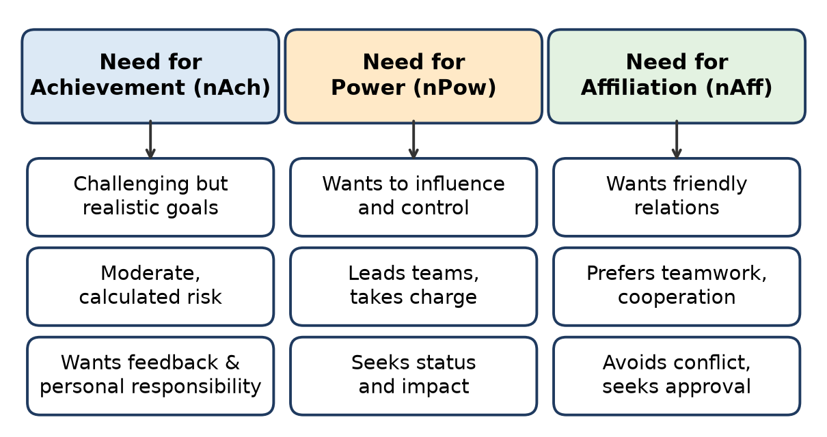
Figure: McClelland's three needs
How high nAch leads to success:
1. Challenging but realistic goals – sets targets that stretch, not impossible ones.
2. Moderate (calculated) risk – avoids gambling and avoids "too safe" choices.
3. Personal responsibility – owns results, does not blame luck.
4. Feedback seeking – tracks sales, profit and customer response, then improves.
5. Innovation – always looks for a better, faster, cheaper way.
6. Persistence – keeps working after failure.
7. Future orientation – plans ahead and uses time well.
Proof: McClelland's Kakinada experiment in India (1960s) showed that achievement-motivation training made businessmen more active and enterprising, so nAch can be developed – the basis of EDP training today.
Example: Nithin Kamath set a bold goal of cheap broking, took a measured risk and kept improving Zerodha's platform using user feedback.
Conclusion: High nAch turns an ordinary person into a goal-driven, risk-aware entrepreneur.
Remember: nAch = "GRRF": Goals, moderate Risk, Responsibility, Feedback.

Q20. An entrepreneur consistently sets challenging goals, takes calculated risks, and seeks regular feedback to improve performance. Explain this entrepreneurial behaviour with reference to McClelland's Need Achievement Theory.
5-7 Marks • L2 Understand • Moderate • CO1
Situation: The entrepreneur shows goal-setting, calculated risk and feedback seeking – the three classic signs of a high Need for Achievement (nAch).
Analysis (McClelland):
Behaviour seen | nAch trait | Why it helps
Sets challenging goals | Prefers tasks of moderate difficulty | Goal is hard enough to be satisfying, but achievable
Takes calculated risks | Moderate risk-taking | Success depends on skill, not luck
Seeks regular feedback | Wants concrete feedback on results | Can correct mistakes quickly
Works to improve | Personal responsibility and innovation | Continuous growth of the venture

Other nAch features likely present: strong self-confidence, persistence, focus on the future and preference for personal accomplishment over money alone (money is seen as a score of success).
Why it matters: Such a person does not depend on others, does not gamble, and keeps learning – which McClelland linked to entrepreneurial success. His Kakinada experiment showed this motivation can be trained.
Example: a Pune startup founder who sets a target of 100 customers in 3 months, tests the product in one area first, and changes it after customer reviews.
Conclusion: The behaviour is a clear case of high nAch, the strongest motive for entrepreneurship.
Remember: Goal + Calculated risk + Feedback = high nAch.

Q21. A startup founder successfully motivates employees by assigning leadership responsibilities, encouraging teamwork, and rewarding outstanding performance. Describe how the three needs proposed by McClelland can be identified in this scenario.
5 Marks • L2 Understand • Moderate • CO1
McClelland's three needs: Achievement, Power, Affiliation. A good founder satisfies each need in the team.
Action of founder | Need satisfied | Explanation
Assigning leadership responsibilities | Need for Power (nPow) | Employees get authority to influence and guide others
Encouraging teamwork | Need for Affiliation (nAff) | Employees feel accepted, friendly relations and belonging
Rewarding outstanding performance | Need for Achievement (nAch) | Employees get recognition and feedback for excellence

Points:
1. nPow – people with high power need enjoy leading projects; giving them a team lead role motivates them.
2. nAff – team events, collaboration and open communication keep such people happy and loyal.
3. nAch – clear targets, performance bonuses and quick feedback drive achievers.
4. The founder thus matches the task to the dominant need of each employee.
Conclusion: By using all three needs, the founder builds a motivated, balanced team.
Remember: Lead = Power, Team = Affiliation, Reward = Achievement.

Q22. Two entrepreneurs exhibit different leadership styles. One enjoys solving challenging problems independently, while the other prefers leading large teams and influencing organizational decisions. Differentiate their dominant motivational needs using McClelland's Need Achievement Theory.
5 Marks • L2 Understand • Moderate • CO1
Entrepreneur 1 has a dominant Need for Achievement (nAch); Entrepreneur 2 has a dominant Need for Power (nPow).
Basis | Entrepreneur 1 – nAch | Entrepreneur 2 – nPow
Main drive | Doing a task better, personal success | Influencing and controlling others
Work style | Works independently, hands-on | Works through people, delegates
Goals | Challenging but realistic tasks | Status, authority, bigger organisation
Feedback | Wants quick feedback on own results | Wants recognition and impact on decisions
Risk | Moderate, calculated | Can take bigger risks for influence
Best role | Technical founder, R&D, product building | CEO, team leader, business expansion

Note: McClelland said socialised power (used for the organisation's good) makes effective leaders, while very high nAch alone may make a person a poor delegator in large firms.
Conclusion: A startup works best when both are combined – the achiever builds the product, the power-oriented leader grows the team.
Remember: Solo problem-solver = nAch; team commander = nPow.

Q23. Discuss the importance of the three motivational needs proposed by McClelland in entrepreneurial development.
5 Marks • L2 Understand • Moderate • CO1
McClelland's needs are learned, so they can be developed through training (EDPs).
1. Need for Achievement (nAch) – most important for entrepreneurs.
- Drives goal-setting, calculated risk, innovation and persistence.
- Helps the person start a venture and keep improving it.
2. Need for Power (nPow) – important for growth stage.
- Helps lead teams, negotiate with investors, suppliers and government.
- Socialised power builds strong organisations (e.g. leading a large company).
3. Need for Affiliation (nAff) – important for networking and teamwork.
- Builds good relations with partners, employees and customers.
- Too much nAff may avoid tough decisions, so it should be moderate.
In entrepreneurial development:
- EDP and incubator training (e.g. EDII Ahmedabad) use achievement-motivation exercises.
- The Kakinada experiment proved nAch can be raised by training.
Remember: Start with Achievement, grow with Power, sustain with Affiliation.

Q24. Explain why individuals with a high Need for Achievement (nAch) are more likely to become successful entrepreneurs than others.
5-7 Marks • L2 Understand • Moderate • CO1
According to McClelland, entrepreneurship needs exactly the traits that high-nAch people naturally have.
1. Goal-oriented – set clear, challenging targets (e.g. "break even in 18 months").
2. Calculated risk-takers – prefer moderate risk where skill matters; avoid both gambling and over-safety.
3. Take personal responsibility – own both success and failure; this is the essence of ownership.
4. Need feedback – business gives quick, measurable feedback (sales, profit), which they enjoy.
5. Innovative – look for better ways, so they find new products and processes.
6. Persistent – failure is treated as learning, not an end.
7. Not money-driven alone – money is a scorecard; the real reward is accomplishment.
Comparison:
High-nAch person | Low-nAch person
Seeks challenge | Seeks security
Moderate risk | Avoids risk or gambles
Wants feedback | Avoids evaluation
Self-driven | Needs outside push

Example: Narayana Murthy left a secure job to start Infosys with just ₹10,000, set high goals of global quality and kept measuring performance.
Conclusion: A business rewards exactly what high-nAch people love – challenge, responsibility and measurable results.
Remember: Business is a scoreboard; high-nAch people love scoreboards.

Topic 5: Case Study of Indian Entrepreneurs in the Pre-Independence and Post-Independence Era (HOTS)

Q25. Compare the entrepreneurial contributions of one entrepreneur from the Pre-Independence Era and one from the Post-Independence Era with reference to opportunity identification, innovation, and risk-taking.
7 Marks • L2 Understand • HOTS • CO1
Jamsetji Tata (1839–1904) – pre-Independence; Dhirubhai Ambani (1932–2002) – post-Independence.
Basis | Jamsetji Tata | Dhirubhai Ambani
Era | British rule, little Indian industry | Licence Raj, then liberalisation (1991)
Opportunity identification | Saw that India exported cotton but imported cloth – set up Empress Mills, Nagpur (1877); saw need for Indian steel, power and science | Saw demand for synthetic (polyester) fabric; began yarn trading (Reliance, 1958), then the Vimal brand
Innovation | Modern mills with new machinery, worker welfare; planned steel plant, hydro power, IISc; built Taj Mahal Hotel (1903) | Backward integration: textiles → polyester → petrochemicals → refining (Jamnagar); retail-investor funding
Risk-taking | Invested in heavy industry when the British discouraged Indian industry | Took huge debt and equity risks; first big public issue (1977) with lakhs of small investors
Legacy | Tata Steel (1907), Tata Power, IISc; "nation-building" | Reliance became one of India's largest private companies; "equity cult"

Common points: both were visionary, took big risks and built industries India lacked.
Conclusion: Jamsetji laid the foundation of Indian industry; Dhirubhai showed how a first-generation entrepreneur could build a giant through scale and public capital.
Remember: Jamsetji = foundations (steel, power, science); Dhirubhai = scale (polyester to petroleum).

Q26. Discuss the contributions of Indian entrepreneurs from the Pre-Independence and Post-Independence eras towards industrial and economic development.
5-7 Marks • L2 Understand • HOTS • CO1
Pre-Independence era (before 1947) – built the base of Indian industry under colonial rule.
1. Jamsetji Tata – textile mills, plans for steel (Tata Steel, 1907), hydro power and IISc; Jamshedpur.
2. G. D. Birla – jute, textiles, sugar; supported the Swadeshi movement.
3. Walchand Hirachand – shipping (Scindia Steam Navigation), aircraft and construction.
4. Contribution: import substitution, first heavy industries, national pride (Swadeshi).
Post-Independence era (after 1947) – growth, scale, technology and global reach.
1. Dhirubhai Ambani – textiles to petrochemicals; small investors in share market.
2. Verghese Kurien – Amul and Operation Flood; India became the world's largest milk producer.
3. Karsanbhai Patel – Nirma, low-cost detergent for the masses.
4. N. R. Narayana Murthy – Infosys; IT services exports, global delivery model.
5. Kiran Mazumdar-Shaw – Biocon, biotechnology.
6. Contribution: employment, exports, forex, technology, cooperative and rural growth.
Conclusion: Pre-Independence entrepreneurs laid the foundation; post-Independence entrepreneurs built the structure of a modern economy.
Remember: Before 1947: build the base; after 1947: build to scale and go global.

Q27. Explain how the entrepreneurial journeys of Jamsetji Tata and Dhirubhai Ambani reflect the changing nature of entrepreneurship across different economic environments.
5-7 Marks • L2 Understand • HOTS • CO1
Jamsetji Tata – colonial economy (19th century)
1. Little industry, British control, no support for Indian business.
2. Entrepreneurship meant nation-building: textiles (Empress Mills, 1877), plans for steel, power and science (IISc).
3. Funded mostly by own and family capital and trusted networks.
4. Strong ethics and welfare – pension and accident schemes for mill workers; wealth went to trusts.
Dhirubhai Ambani – independent India (1958–2002)
1. Licence Raj till 1991 – permits and quotas controlled industry; later liberalisation.
2. Started as a first-generation trader with little capital, built Reliance.
3. Raised money from lakhs of small shareholders (public issue, 1977) – new style of finance.
4. Focus on scale, speed and backward integration (polyester to refinery).
What changed:
Aspect | Then (Jamsetji) | Later (Dhirubhai)
Environment | Colonial, hostile | Regulated, then liberalised
Finance | Own / family funds | Public equity and debt
Goal | Industrialise the nation | Scale and market leadership
Background | Business family | First-generation trader

Conclusion: Entrepreneurship changed from family-funded nation-building to market-funded large-scale growth as the economy opened up.
Remember: Environment shapes the entrepreneur: colony → nation-builder; Licence Raj → system-navigator.

Q28. Describe the entrepreneurial lessons that can be learned from any two Indian entrepreneurs studied in this chapter.
7 Marks • L2 Understand • HOTS • CO1
1. Jamsetji Tata – lessons:
- Think long-term – planned steel, power and IISc decades ahead.
- Business with ethics – fair wages, worker welfare, trust-based ownership.
- Society first – profits shared with the nation through philanthropy.
- Quality and modern technology – used the best machinery of his time.
2. N. R. Narayana Murthy (Infosys) – lessons:
- Start small, dream big – Infosys began in 1981 with about ₹10,000.
- Teamwork – seven co-founders with complementary skills.
- Value-based leadership and transparency – honest accounts and clear disclosure built investor trust; Infosys became the first Indian company listed on NASDAQ (1999).
- Share wealth – ESOPs made employees owners.
- Persistence – survived early years of slow growth and government restrictions on imports of computers.
Common lessons for a student entrepreneur:
Lesson | Practical action
Vision | Write a clear long-term goal
Ethics | Never compromise on honesty and compliance
People | Build a team and share rewards
Patience | Expect slow early growth

Conclusion: Success that lasts comes from vision + values + team.
Remember: Tata teaches "give back"; Murthy teaches "be transparent and share".

Q29. Explain the role of entrepreneurship in economic development with reference to the contributions of one Pre-Independence and one Post-Independence Indian entrepreneur.
5-7 Marks • L2 Understand • HOTS • CO1
Entrepreneurship drives economic development through jobs, industry, innovation, exports and social welfare.
Pre-Independence – Jamsetji Tata
1. Industrialisation – Empress Mills (1877); vision for Tata Steel (1907), India's first integrated steel plant.
2. Regional development – Jamshedpur grew as a planned industrial city.
3. Infrastructure – hydro-electric power for Mumbai (Tata Power).
4. Human capital – idea of the Indian Institute of Science, Bengaluru.
Post-Independence – N. R. Narayana Murthy (Infosys)
1. Employment – Infosys employs over three lakh people.
2. Exports and forex – most revenue earned from foreign clients; helped build India's IT export industry.
3. Wealth creation – ESOPs and public listing created wealth for employees and investors.
4. Global image – Global Delivery Model made India a trusted IT destination.
Comparison of contribution:
Role in development | Jamsetji Tata | Narayana Murthy
Sector | Heavy industry | IT services
Main impact | Industrial base | Exports and skilled jobs
Social impact | Trusts and welfare | ESOPs and philanthropy

Conclusion: Both show that entrepreneurs convert vision into national growth.
Remember: Steel built India's base; software built India's brand.

Q30. Compare the entrepreneurial philosophies of N. R. Narayana Murthy and Jamsetji Tata with respect to leadership, ethics, and business growth.
7 Marks • L2 Understand • HOTS • CO1
Basis | Jamsetji Tata | N. R. Narayana Murthy
Leadership | Visionary and nation-builder; planned industries for India's future | Lead by example; simple lifestyle, meritocracy, teamwork among seven co-founders
Ethics | Business for the community; worker welfare and pension schemes; wealth placed in trusts | Transparency and corporate governance; honest disclosure; "compassionate capitalism"
Business growth | Diversified into textiles, hotels, steel, power, science – long-term, capital-heavy | Focused on IT services, global clients, Global Delivery Model; NASDAQ listing (1999)
Wealth sharing | Philanthropy through trusts | ESOPs – employees became shareholders
Era | Colonial India, little industry | Liberalising India, global IT boom

Similarities:
1. Both placed values above short-term profit.
2. Both saw business as a way to serve society and the nation.
3. Both built institutions that outlived the founder.
Differences: Jamsetji's growth was through diversified heavy industry; Murthy's through focused, knowledge-based services.
Conclusion: Different eras, same core – ethical leadership creates lasting enterprises.
Remember: Tata = trust and nation-building; Murthy = transparency and sharing.

Quick Revision – Unit 1
Term | Key fact
Entrepreneurship | Spotting an opportunity, taking risk and organising resources to create value
Cantillon | Entrepreneur = risk-bearer (buys at certain price, sells at uncertain price)
Schumpeter | Entrepreneur = innovator, "new combinations"
Drucker | Searches for change, exploits it as an opportunity
Core elements | Opportunity, Innovation, Risk, Resources, Vision, Value
4 Industrial Revolutions | Steam (1760) → Electricity (1870) → Computers (1969) → AI/IoT (2011)
Economic role | Jobs, wealth/GDP, innovation, regional development, exports, social development
McClelland | Three learned needs: Achievement, Power, Affiliation (The Achieving Society, 1961)
High nAch traits | Challenging goals, moderate risk, feedback, personal responsibility
Kakinada experiment | Showed nAch can be developed by training
Jamsetji Tata | Empress Mills 1877; vision for Tata Steel, Tata Power, IISc
Dhirubhai Ambani | Reliance; backward integration; 1977 public issue with small investors
Narayana Murthy | Infosys 1981 with about ₹10,000; transparency, ESOPs, NASDAQ 1999
Verghese Kurien | Amul, Operation Flood – milk cooperative movement

Unit 2: Entrepreneur concept

Topic 1: Why Become an Entrepreneur?

Q1. Summarise any six reasons for becoming an entrepreneur, with a suitable example for each.
3 Marks • L2 Understand • CO2
Reason | Example
1. Independence – be your own boss | Ritesh Agarwal started OYO instead of taking a job
2. Wealth creation – unlimited earning potential | Dhirubhai Ambani rose from a trader to build Reliance
3. Passion / idea – turn an idea into reality | Nithin Kamath built Zerodha from his trading experience
4. Solving a social problem | Aravind Eye Care – low-cost eye surgery
5. Recognition and status | Kiran Mazumdar-Shaw became a global biotech leader (Biocon)
6. Job creation / family need – unemployment or family income | Lijjat Papad women started to earn for their families

Remember: Six reasons = "I W P S R J": Independence, Wealth, Passion, Social, Recognition, Jobs.

Q2. "Innovation is an engine of entrepreneurship." Examine the statement from the perspective of becoming an entrepreneur with a suitable example.
4 Marks • L3 Apply • CO2
Innovation means doing something new or better – a new product, process, market or business model. Schumpeter and Drucker both called innovation the specific tool of the entrepreneur.
Why innovation is the "engine":
1. Creates the opportunity – a new idea gives a reason to start a venture.
2. Competitive advantage – a new entrant cannot beat big firms by copying; it must be different.
3. Creates new markets – customers who were not served before.
4. Drives growth – continuous innovation keeps the business alive (Nokia and Kodak fell when they stopped).
5. Attracts funding and support – investors and Startup India back innovative ideas.
Example – Zerodha (2010): Instead of charging a percentage of trade value, it charged zero brokerage on delivery and a flat fee on intraday trades, with an easy online platform. This business-model innovation made it one of India's largest brokers without outside funding.
Remember: No innovation, no reason to exist – innovation is the fuel, entrepreneur is the vehicle.

Q3. Interpret the term entrepreneur and list any two personal traits that support entrepreneurship.
3 Marks • L2 Understand • CO2
Entrepreneur: A person who identifies an opportunity, organises resources and bears the risk of starting and running a new business, in return for profit and satisfaction. The word comes from the French entreprendre – "to undertake".
Two personal traits:
1. Risk-taking ability – ready to invest time and money under uncertainty, but with calculation.
2. Need for achievement / self-confidence – sets high goals and believes in his own ability to reach them.
(Other traits: creativity, persistence, leadership, adaptability.)
Remember: Entrepreneur = "undertaker" of a venture – brave + confident.

Q4. A group of engineering graduates develops an affordable machine to solve a problem faced by small farmers. Illustrate what can motivate them to become entrepreneurs.
4 Marks • L3 Apply • CO2
Situation: Young engineers have a low-cost farm machine that solves a real problem.
Motivating factors:
1. Clear market opportunity (pull) – India has crores of small and marginal farmers who cannot afford costly machines.
2. Social impact – reduces farmers' labour and cost, raises their income.
3. Use of technical skills – they can apply engineering knowledge directly.
4. Independence and ownership – build their own company rather than work for others.
5. Financial reward – large volumes can bring good profit.
6. Government support – Startup India, Atal Innovation Mission incubators, Mudra loans, grants for agri-tech.
7. Recognition – awards, media and investor attention for agri-innovation.
8. Team strength – a group shares risk and combines skills (design, finance, marketing).
Example of such motivation: agri-tech ventures like DeHaat grew by serving small farmers.
Remember: Problem + Skill + Support = motivation to start.

Topic 2: Entrepreneur vs Entrepreneurship, Entrepreneur vs Manager

Q5. Classify the following roles as Entrepreneur, Businessman, or Manager: a person who starts a new venture, a person who operates an existing business for profit, and a person who manages employees and resources.
4 Marks • L3 Apply • CO2
Role described | Classification | Reason
Starts a new venture | Entrepreneur | Creates something new, takes the starting risk, innovates
Operates an existing business for profit | Businessman | Runs an established business; focus on profit, little innovation
Manages employees and resources | Manager | Salaried employee who plans, organises and controls for the owner

Key differences:
1. Risk – entrepreneur highest, businessman moderate, manager none (salary is fixed).
2. Innovation – entrepreneur high, businessman low, manager works within the system.
3. Ownership – entrepreneur and businessman own; manager does not.
4. Example – Ritesh Agarwal founding OYO (entrepreneur); a shopkeeper running his father's cloth shop (businessman); a branch manager of a bank (manager).
Remember: Starts = Entrepreneur, Runs = Businessman, Manages = Manager.

Q6. Differentiate between an entrepreneur and a businessman.
3 Marks • L2 Understand • CO2
Basis | Entrepreneur | Businessman
Idea | Original, new idea | Existing, tested idea
Innovation | High | Low
Risk | High (new market) | Moderate (known market)
Focus | Value creation, change | Profit from current trade
Market position | Market creator / leader | Market player / follower
Example | Deepinder Goyal (Zomato) | Owner of a franchise grocery store

Conclusion: Every entrepreneur is a businessman, but not every businessman is an entrepreneur.
Remember: Entrepreneur creates the road; businessman drives on it.

Q7. A student notices a business opportunity and decides to establish a new venture. As the venture grows, another person is appointed to plan and manage its day-to-day activities. Illustrate the roles of the two individuals and the business entity in this situation.
4 Marks • L3 Apply • CO2
Three players:
1. Student = Entrepreneur
- Spots the opportunity and creates the venture.
- Bears the risk, invests capital, owns the business.
- Gives vision, takes big decisions, raises funds.
- Earns profit (uncertain).
2. Appointed person = Manager
- Plans, organises, directs and controls daily operations.
- Manages staff, budgets, schedules and customers.
- Works for a salary, bears no ownership risk.
- Converts the entrepreneur's vision into results.
3. Business entity = Enterprise
- The organisation itself (e.g. registered as an LLP or Private Limited Company).
- Owns assets, signs contracts, employs people, pays taxes.
- A company or LLP is a separate legal entity – it continues even if people change.
Flow: Entrepreneur creates → Enterprise exists → Manager runs.
Remember: Founder = vision + risk; Manager = execution + salary; Enterprise = the vehicle.

Q8. Compare - Enterprise, Entrepreneurship, Entrepreneur, Businessman, Manager on following points: Meaning; focus; nature, risk, time orientation, role, example.
3 Marks • L2 Understand • CO2
Point | Enterprise | Entrepreneurship | Entrepreneur | Businessman | Manager
Meaning | Business unit created | Process of creating a venture | Person who starts it | Person running an existing business | Salaried person running operations
Focus | Producing goods / services | Innovation, value | Opportunity | Profit | Efficiency
Nature | Organisation (output) | Activity / process | Creator, innovator | Trader, operator | Executor, coordinator
Risk | Business risk of the unit | Risk is inherent | Bears full risk | Moderate risk | No ownership risk
Time orientation | Ongoing | Future | Long-term future | Present | Short to medium term
Role | Vehicle of business | Function | Founder, owner | Owner-operator | Planner, controller
Example | Infosys Ltd | Building Infosys | Narayana Murthy | A local dealer | Infosys project manager

Conclusion: The entrepreneur does entrepreneurship to create an enterprise, which a manager runs; a businessman runs an existing one.
Remember: Person (entrepreneur) → Process (entrepreneurship) → Product (enterprise).

Topic 3: Types of Entrepreneurs

Q9. Associate the below entrepreneurs according to the appropriate types. (Table: Karsanbhai Patel – Nirma; Ritesh Agarwal – OYO Rooms; Kiran Mazumdar-Shaw – Biocon; Verghese Kurien – Amul; Dhirubhai Ambani – Reliance Industries; Narayana Murthy – Infosys)
3 Marks • L2 Understand • CO2
Entrepreneur | Enterprise | Type of Entrepreneur
Karsanbhai Patel | Nirma | First-generation manufacturing entrepreneur – low-cost detergent for the masses
Ritesh Agarwal | OYO Rooms | Young tech / startup (service) entrepreneur – app-based hotel network
Kiran Mazumdar-Shaw | Biocon | Woman and technical (biotech) entrepreneur
Verghese Kurien | Amul | Social / cooperative (rural) entrepreneur – farmer-owned dairy
Dhirubhai Ambani | Reliance Industries | First-generation industrial entrepreneur – trading to large-scale manufacturing
Narayana Murthy | Infosys | Technopreneur / professional entrepreneur – IT services

By Danhof's behaviour types, most of them are innovative entrepreneurs.
Remember: Nirma = mass, OYO = app, Biocon = biotech woman, Amul = cooperative, Reliance = industry, Infosys = IT.

Q10. Present a contrast between different entrepreneurs based on the nature of business, ownership and size with suitable examples.
3 Marks • L2 Understand • CO2
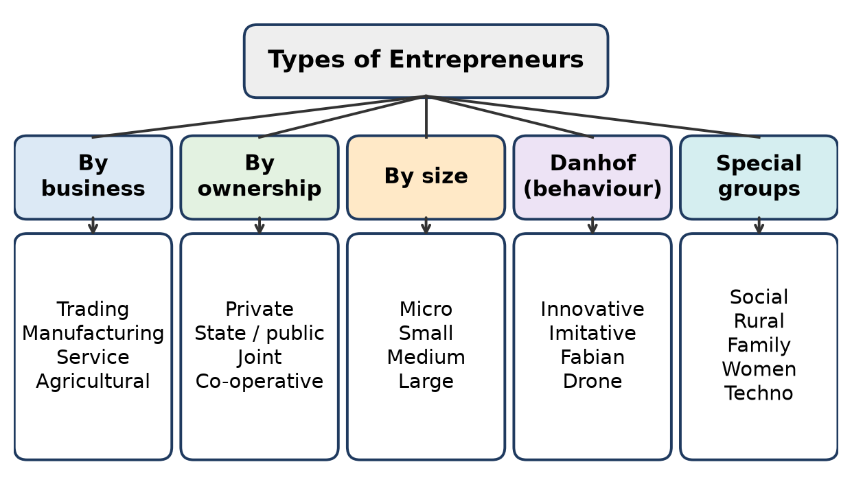
Figure: Types of entrepreneurs
Basis | Types | Example
Nature of business | Trading (buy and sell), Manufacturing (make goods), Service, Agricultural | D-Mart; Nirma; OYO; Amul dairy
Ownership | Private (individual / group), State / public (government), Joint (private + government), Co-operative (members) | Reliance; ONGC; Maruti Suzuki (started as a government–Suzuki joint venture); Amul
Size (MSME limits, revised 2025) | Micro (investment ≤ ₹2.5 crore, turnover ≤ ₹10 crore), Small (≤ ₹25 crore / ≤ ₹100 crore), Medium (≤ ₹125 crore / ≤ ₹500 crore), Large (above) | Local bakery; auto-parts supplier; Tata Steel

Remember: Classify by WHAT (business), WHO (owner), HOW BIG (size).

Q11. A social entrepreneur launches an affordable healthcare service for low-income communities. Analyze the possible challenges that the social entrepreneur may face in sustaining the venture.
4 Marks • L4 Analyse • CO2
Situation: Low-cost healthcare for poor communities – the aim is social value first, but the venture must also survive financially.
Challenges:
1. Financial sustainability – low prices mean thin margins; dependence on grants and donations is risky.
2. Funding – investors prefer high-return ventures; social ventures get less capital.
3. Skilled staff – doctors and nurses prefer cities and higher salaries.
4. Scaling up – expanding to more villages needs money, systems and trust.
5. Low awareness and trust – patients may delay treatment or prefer local quacks.
6. Regulation – licences for clinics, drugs and diagnostics (Clinical Establishments rules, Drugs and Cosmetics Act).
7. Measuring impact – donors want proof of social results.
8. Mission drift – pressure to earn may push prices up and drive away the poor.
Ways to sustain: cross-subsidy (richer patients pay more, like Aravind Eye Care), high volume with low cost, trained paramedics, telemedicine and CSR partnerships.
Remember: Social venture must balance "mission and money".

Q12. Different entrepreneurial approaches are adopted to create social value, develop rural communities, and sustain family-owned businesses. Categorize the three types of entrepreneurs according to their primary focus and state one distinguishing feature of each.
4 Marks • L4 Analyse • CO2
Type | Primary focus | Distinguishing feature | Example
Social entrepreneur | Solving a social problem (social value) | Success is measured by social impact, profit is a means | Aravind Eye Care, SELCO India
Rural entrepreneur | Developing rural areas using local resources | Uses local raw material, labour and skills; reduces migration | Amul (village milk societies), Lijjat Papad origins
Family business entrepreneur | Growth and continuity of a family-owned business | Ownership and control pass across generations | Tata, Godrej, Dabur, Haldiram's

Analysis:
- Social = why (purpose); Rural = where (location); Family = who (ownership).
- One venture can belong to more than one type, e.g. a rural social enterprise.
Remember: Social = purpose, Rural = place, Family = people (generations).

Q13. A rural entrepreneur has limited access to finance and technology but possesses strong local knowledge, community support, and access to local resources. Analyze how these factors can influence the success of the venture.
4 Marks • L4 Analyse • CO2
Situation: Weaknesses in finance and technology, strengths in local knowledge, community and resources.
Positive factors (strengths):
1. Local knowledge – knows customer needs, prices, seasons and suppliers, so products fit the market.
2. Community support – trust, word-of-mouth sales, cheap local labour, help in tough times.
3. Local resources – cheap raw material (milk, crops, bamboo, clay) lowers cost and transport.
4. Low competition – fewer organised players in villages.
Negative factors (weaknesses):
1. Limited finance – cannot buy machines or hold stock; growth is slow.
2. Limited technology – low productivity, poor quality and packaging, difficulty reaching city markets.
Net effect: Strengths help the venture start and survive; weaknesses limit growth and scale.
Ways to overcome weaknesses: Mudra loans, NABARD and bank schemes, self-help groups, cooperatives, Khadi and Village Industries Commission (KVIC) support, training at rural self-employment institutes, and digital platforms for marketing.
Example: Amul began with small farmers pooling milk – community strength overcame lack of capital.
Remember: Local strengths start the venture; finance and technology scale it.

Q14. A family-owned enterprise aims to expand its business while preserving family involvement and ensuring continuity across generations. Analyze the key factors that make this approach different from social and rural entrepreneurship.
4 Marks • L4 Analyse • CO2
Family business entrepreneurship focuses on family ownership, control and succession.
Key distinguishing factors:
1. Ownership and control – held by family members; decisions often by the family head.
2. Succession planning – passing leadership to the next generation is central.
3. Family values and reputation – brand trust is built over generations (e.g. Haldiram's, Dabur).
4. Patient capital – family funds and long-term outlook, less pressure for quick returns.
5. Family conflicts – disputes over property and control are a special risk.
6. Professionalisation – to grow, families appoint outside professional managers.
Basis | Family business | Social | Rural
Main aim | Growth and continuity of family wealth | Social impact | Rural development
Ownership | Family | Founder / trust / company | Individual / cooperative
Success measure | Profit and survival across generations | Lives improved | Local jobs and income
Location | Anywhere | Anywhere | Villages

Remember: Family business = "keep it in the family, keep it growing".

Q15. A rural entrepreneur has limited access to finance and technology but possesses strong local knowledge, community support, and access to local resources. Analyze how these factors can influence the success of the venture.
4 Marks • L4 Analyse • CO2
Same as Q13 above.
Extra point: The entrepreneur can turn community support into finance by forming a self-help group or cooperative (pooled savings and easier bank credit), and can turn local knowledge into a brand (e.g. a GI-tagged local product) sold online.
Remember: Community can be capital – pool it.

Topic 4: The Entrepreneurial Decision Process

Q16. Break down various push and pull factors to become an entrepreneur.
5 Marks • L4 Analyse • CO2
The decision to become an entrepreneur starts with a change from the present activity, caused by push or pull factors (Hisrich & Peters).
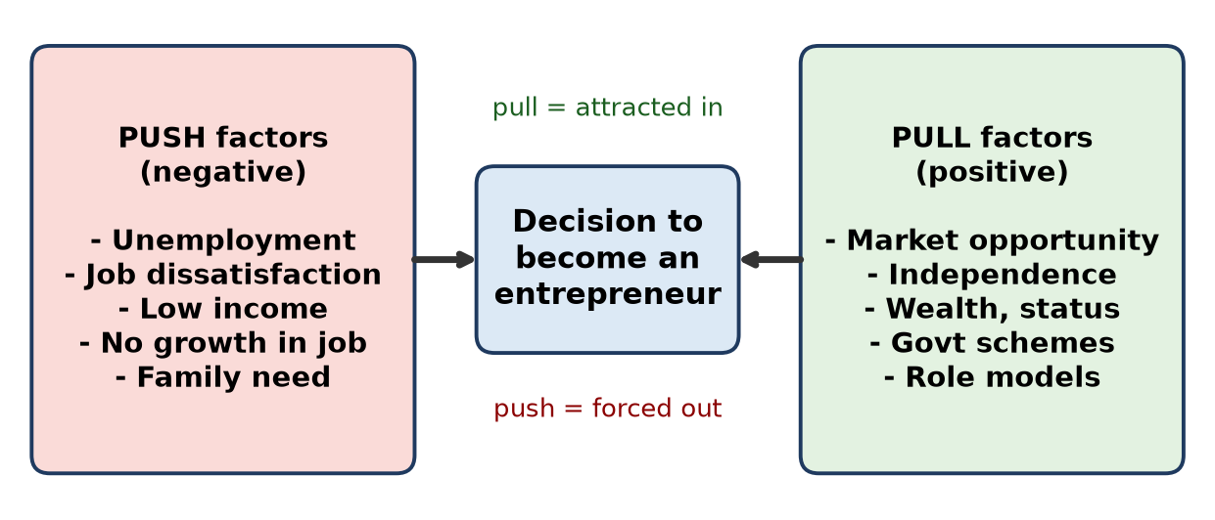
Figure: Push and pull factors
Push factors (negative – forced into business):
1. Unemployment or job loss.
2. Job dissatisfaction – poor pay, no growth, bad boss.
3. Low family income or financial need.
4. Lack of recognition in a job.
5. Migration / displacement – starting fresh in a new place.
Pull factors (positive – attracted to business):
1. Market opportunity – unmet demand.
2. Independence – be your own boss.
3. Wealth and status – higher earning potential.
4. Government support – Startup India, Mudra, PMEGP, subsidies.
5. Role models and family background – success stories inspire.
6. Passion and innovation – desire to build an idea.
Analysis: Pull-driven entrepreneurs usually build more innovative, growth-oriented ventures; push-driven ones often start survival businesses. Most people experience a mix of both.
Remember: Push = pain (forced out); Pull = gain (attracted in).

Q17. A student develops a low-cost agricultural device after observing difficulties faced by farmers. The student identifies a market opportunity and begins planning a venture. Outline the stages of the entrepreneurial decision process represented in this situation.
5 Marks • L4 Analyse • CO2
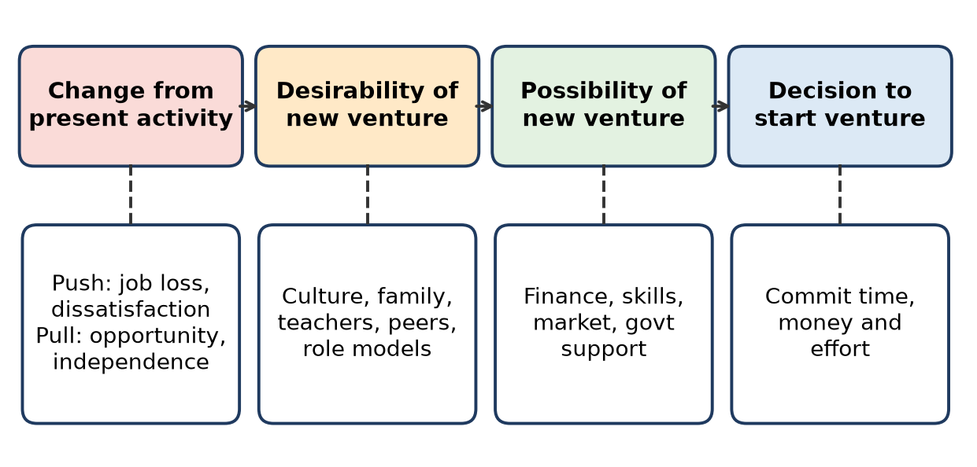
Figure: Entrepreneurial decision process
Stages seen in the situation:
1. Change from present activity – the student moves from studies to business; pull factor = farmers' problem seen as an opportunity.
2. Desirability of a new venture – the student wants to help farmers and be independent; supported by teachers, family, college incubator.
3. Possibility of a new venture – a low-cost device exists (technical skill), market of small farmers, government schemes (Startup India, agri-tech grants) make it possible.
4. Decision to start – the student begins planning.
Next stages of the entrepreneurial process:
5. Opportunity evaluation – market size, price farmers can pay, competition.
6. Business plan – production, marketing, finance.
7. Resource mobilisation – funds, workshop, suppliers, team.
8. Launch and manage – pilot in a few villages, then scale.
Remember: Change → Desirable → Possible → Decide → Plan → Resource → Launch.

Q18. Lijjat Papad was started by seven women in 1959 with a small-scale production activity and gradually expanded into a large cooperative enterprise. Imagine you are part of the founding team just before the first product is taken to the market. Outline the key activities that must be completed to launch the enterprise successfully.
5 Marks • L4 Analyse • CO2
Situation: Seven women in Mumbai, small loan (₹80), home-style papad – first batch ready for market.
Key activities before launch:
1. Fix the product and quality standard – same taste, size and hygiene in every batch (Lijjat's lasting principle: no compromise on quality).
2. Arrange raw material – buy urad dal flour, spices and oil at good rates; keep stock.
3. Organise production – divide work: dough making, rolling at home, drying, packing.
4. Costing and pricing – calculate cost per packet and fix a price that covers cost and is affordable.
5. Packaging and name – simple clean packets with a brand name.
6. Find buyers / distribution – tie up with local merchants and shops; first sales to a known trader.
7. Record keeping – daily accounts of money, stock and sales.
8. Agree on rules among members – profit sharing, equal ownership, discipline.
9. Plan for growth – add new members, sell surplus, collect customer feedback.
Remember: Product → Material → Production → Price → Pack → Place → Records → Rules.

Q19. Nithin Kamath identified high brokerage fees as a problem and developed a discount-brokerage model before launching Zerodha. Break down the major stages of the entrepreneurial decision process reflected in this example.
5 Marks • L4 Analyse • CO2
Stage | What happened in Zerodha
1. Change from present activity (push / pull) | Nithin Kamath was an active trader and sub-broker; frustrated by high brokerage – pull of a big opportunity
2. Opportunity identification | Traditional brokers charged a percentage of trade value; small investors were overcharged
3. Desirability | Personal trading experience, passion for markets, wish to make investing fair and simple
4. Possibility / feasibility | Online trading technology, growing internet users, SEBI broking rules allowed a discount model
5. Decision and business model | Launched Zerodha in 2010 with brother Nikhil: zero brokerage on delivery, flat fee on intraday / F&O
6. Resource mobilisation | Bootstrapped (own funds, no venture capital), small tech team
7. Launch and manage | Built Kite platform, free education (Varsity), grew by word of mouth to one of India's largest brokers

Analysis: The problem came from personal experience, the solution was a business-model innovation, and low cost came from technology.
Remember: Pain (high fees) → Plan (flat fee) → Platform (Kite) → Profit.

Q20. Zomato began as a platform for accessing restaurant information and later expanded into food delivery and other services. Analyze the major resources that would be required to transform such a platform into a scalable business.
5 Marks • L4 Analyse • CO2
Background: Started in 2008 as Foodiebay (online restaurant menus), renamed Zomato, began food delivery around 2015 and later grew into quick-commerce (Blinkit).
Resources needed to scale:
1. Financial resources – large venture capital to fund expansion, discounts and losses in early years; later an IPO (2021).
2. Technology resources – app, ordering system, payment gateway, GPS-based delivery routing, data analytics, cloud servers.
3. Human resources – engineers, sales teams to sign restaurants, customer support, and lakhs of delivery partners.
4. Network resources – thousands of partner restaurants in each city (supply side) and millions of users (demand side).
5. Logistics resources – delivery fleet management, hub locations.
6. Brand and marketing – strong brand, advertising, loyalty programmes.
7. Data resources – reviews, ratings and order history to personalise and price.
8. Legal / regulatory – FSSAI-linked restaurant compliance, GST (e-commerce operator rules), consumer protection rules.
Analysis: The key scalable assets are technology + network effects + capital; delivery adds heavy operating cost, so unit economics must be watched.
Remember: Scale needs "Money, Machines (tech), Manpower, Market network".

Q21. In 1981, seven engineers came together with a shared vision to establish Infosys. With limited initial capital, they began with software projects and gradually built customer trust and expanded into a global IT company. Illustrate the role of business planning and resource mobilization in this entrepreneurial journey.
7 Marks • L4 Analyse • CO2
Situation: Infosys was founded in Pune in 1981 by N. R. Narayana Murthy and six colleagues with about ₹10,000 (borrowed by Murthy from his wife Sudha Murty).
Role of business planning:
1. Clear vision – to build a world-class, ethical software services firm.
2. Target market – overseas clients (first client was in the USA), because Indian demand for software was small.
3. Service model – custom software projects; later the Global Delivery Model (work split between client site and India to cut cost).
4. Quality focus – planned for international quality standards to win trust.
5. Growth plan – moved to Bengaluru (1983); listed on Indian exchanges (1993) and on NASDAQ (1999).
Role of resource mobilisation:
Resource | How Infosys mobilised it
Finance | Founders' small savings; later public issue (IPO) and retained profits
Human | Seven founders with complementary skills; hired bright engineers, trained them; ESOPs to retain talent
Technology | Imported computers despite licence delays of the 1980s
Customers | Built trust project by project; repeat business from foreign clients
Reputation | Transparent accounts and governance attracted investors

Analysis: Planning gave direction, resource mobilisation gave fuel. Little money was overcome by people, quality and trust.
Conclusion: Infosys shows that sound planning + smart use of limited resources can turn a small start into a global company.
Remember: Plan the path, mobilise the people – capital follows trust.

Q22. A student notices that many commuters in his locality spend considerable time waiting for public transport. He considers developing a service to address the problem. Illustrate the steps the student should follow to convert this observation into an entrepreneurial opportunity.
7 Marks • L4 Analyse • CO2
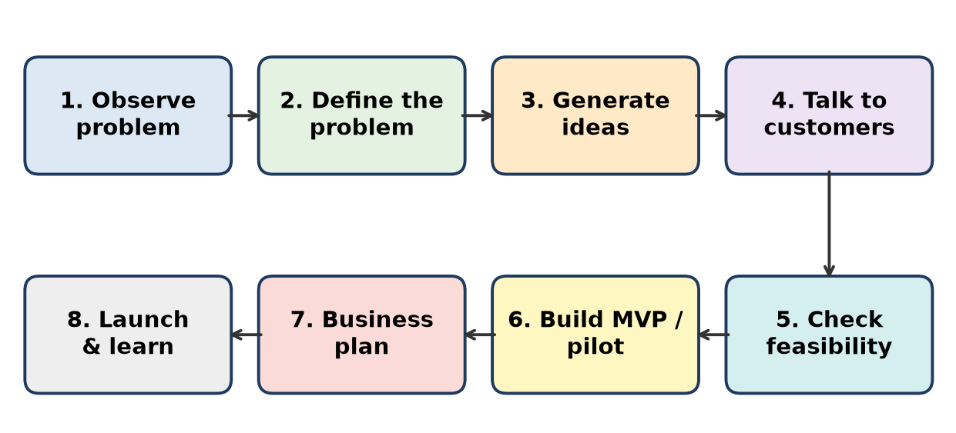
Figure: Converting an observation into an opportunity
Steps:
1. Observe the problem – long waiting time at bus stops in the locality.
2. Define the problem – Who suffers (office-goers, students)? When (peak hours)? How much time is lost? Why (irregular buses, no information)?
3. Generate ideas – real-time bus-tracking app, shared shuttle service, e-rickshaw feeder service, bike-taxi pooling.
4. Talk to customers (validation) – survey 100–200 commuters: will they pay? how much? which option do they prefer?
5. Check feasibility –
- Market: number of daily commuters, competitors (Ola, Uber, Rapido, city bus app).
- Technical: app and GPS, vehicles.
- Financial: cost per trip vs fare.
- Legal: transport permits, RTO rules, insurance.
6. Build an MVP / pilot – run 2–3 shuttles on one route for a month; collect feedback.
7. Prepare a business plan – revenue model (per ride or monthly pass), marketing, funding needs.
8. Launch and learn – start on high-demand routes, track data, improve and expand.
Example idea: a feeder shuttle linking the locality to the metro station on a monthly pass, booked through an app.
Conclusion: An observation becomes an opportunity only after validation with real customers and a feasible, profitable model.
Remember: Observe → Define → Ideate → Validate → Test → Plan → Launch.

Q23. An engineering student wants to start a venture but has not yet decided what business to pursue. During a visit to a local industrial area, the student observes several recurring problems faced by workers and customers. Illustrate a systematic approach the student can use to identify a suitable entrepreneurial opportunity.
7 Marks • L4 Analyse • CO2
Systematic approach:
1. List all problems seen – e.g. machine breakdowns, lack of spare parts, poor canteen food, unsafe working conditions, delays in delivery to customers, waste disposal.
2. Group and study each problem – talk to workers, supervisors and owners; note frequency, cost and urgency.
3. Screen problems using criteria – score each problem:
Problem | Market size | Willingness to pay | Fit with my skills | Competition | Total (out of 20)
Machine breakdowns (predictive maintenance) | 5 | 5 | 5 | 3 | 18
Poor canteen food | 3 | 3 | 2 | 2 | 10
Waste disposal | 4 | 3 | 3 | 3 | 13

4. Choose the best opportunity – here, a low-cost IoT sensor for predictive maintenance of machines in small factories.
5. Validate – meet 10–20 MSME owners, ask about downtime cost and price they would pay.
6. Feasibility study – technical (sensor + app), financial (cost, price, break-even), legal.
7. Prototype / MVP – install in 2–3 units free or at low cost; measure results.
8. Business plan and launch – pricing model (sale or monthly subscription), sales channel, funding (college incubator, Startup India seed fund).
Conclusion: A structured screening of real problems leads to an opportunity that matches market need and the student's skills.
Remember: List → Study → Score → Select → Validate → Prototype → Plan.

Topic 5: Case Study of Entrepreneurship in Different Sectors

Q24. Flipkart began as an online platform for selling books and later expanded into a large e-commerce marketplace. Analyze the entrepreneurial opportunity that enabled the venture to expand beyond its initial business model.
5 Marks • L4 Analyse • CO2
Background: Founded in 2007 in Bengaluru by Sachin Bansal and Binny Bansal; began by selling books online.
Opportunity that allowed expansion:
1. Growing internet and smartphone users – a huge new online customer base.
2. Poor retail access – small towns lacked choice of products; online gave access.
3. Trust gap solved by innovation – cash on delivery, easy returns and own logistics (Ekart) built trust when people feared online payment.
4. Books as a low-risk start – standard products, easy to ship; taught them logistics and customer service.
5. Scaling to new categories – electronics, mobiles, fashion (acquired Myntra), appliances.
6. Marketplace model – allowed thousands of third-party sellers, so variety grew without owning all stock.
7. Investment and partnerships – venture funding; Walmart bought a majority stake in 2018.
Analysis: The real opportunity was not books but India's under-served retail market + digital adoption; books were the entry point.
Remember: Books were the door; India's e-commerce boom was the house.

Q25. Two entrepreneurs identify the problem of low agricultural productivity. The first develops smart farming equipment, while the second develops a digital platform connecting farmers with agricultural experts and markets. Analyze how the entrepreneurial opportunities of the two ventures differ despite addressing the same broad problem.
5 Marks • L4 Analyse • CO2
Basis | Venture 1 – Smart farming equipment | Venture 2 – Digital platform
Type of opportunity | Product / hardware innovation | Service / platform innovation
Value created | Saves labour, water and inputs; higher yield per acre | Better advice, better prices, access to buyers
Customer | Farmers who can buy or rent machines | Farmers, experts and buyers (multi-sided)
Capital need | High – design, manufacturing, inventory | Lower – software, but needs marketing and network
Revenue model | Sale, rental or leasing of equipment | Commission, subscription, advisory fees, input sales
Scalability | Slower – production and service network | Faster – network effects online
Key risks | High price for small farmers, maintenance | Low digital literacy, trust, internet access
Example | Drones, sensor-based irrigation | DeHaat-type agri platforms

Analysis: Same problem, different root cause targeted – Venture 1 fixes farm operations, Venture 2 fixes information and market access. Both can even work together.
Remember: Same problem, two doors: machine for the field, app for the market.

Q26. Aravind Eye Care System developed a model for providing affordable eye-care services to a large number of patients, including people from economically weaker sections. Analyze the entrepreneurial approach adopted by Aravind Eye Care to create both social and economic value.
5 Marks • L4 Analyse • CO2
Background: Founded by Dr G. Venkataswamy in Madurai in 1976 as an 11-bed hospital; aim – eliminate needless blindness.
Entrepreneurial approach:
1. Cross-subsidy model – paying patients get extra comfort; their fees cover free or low-cost surgery for the poor.
2. High volume, low cost – standardised, assembly-line style surgery; each surgeon does many more operations than average.
3. Task-shifting – trained paramedics (mid-level ophthalmic staff) do routine work so doctors focus on surgery.
4. Backward integration – Aurolab (1992) makes intraocular lenses at a fraction of imported cost.
5. Outreach – eye camps and vision centres in villages bring in patients.
6. Quality – good outcomes build trust, so paying patients also come.
Value created:
- Social: sight restored for lakhs of poor patients; jobs for rural women as paramedics.
- Economic: financially self-sustaining without depending on donations.
Remember: Aravind = "Rich pay, poor pay little, everyone sees" – volume makes it work.

Q27. A city faces increasing waste generation and rising costs of waste management. An engineering startup proposes a business that collects segregated waste, processes recyclable material and converts organic waste into useful products. Outline the entrepreneurial potential of the proposed venture from the perspective of sustainability and value creation.
5 Marks • L4 Analyse • CO2
Opportunity: Growing waste + rising municipal cost + rules on segregation (Solid Waste Management Rules, 2016) + Swachh Bharat Mission = large market.
Value creation (revenue streams):
1. Collection fees from housing societies, offices, hotels (bulk waste generators).
2. Recyclables – plastic, paper, metal, glass sold to recyclers.
3. Organic waste → compost / biogas – sold to farmers, nurseries, or used as fuel.
4. Contracts with municipal corporations.
5. Extended Producer Responsibility (EPR) – brands pay to have plastic waste collected and recycled.
6. Carbon credits (possible in future).
Sustainability (triple bottom line):
- Environmental – less landfill, less methane, resource recovery (circular economy).
- Social – jobs and safer work for waste pickers, cleaner city.
- Economic – multiple revenue streams, low raw-material cost (waste is free or paid for).
Challenges: poor segregation at source, capital for plants, permits, price changes of recyclables.
Remember: Waste is a resource in the wrong place – the startup puts it right and earns.

Q28. A city faces increasing problems related to waste generation, air pollution, and inefficient resource use. An engineering startup wants to develop a business solution addressing these problems. Examine a suitable entrepreneurial sector and a possible value-creating solution.
7 Marks • L3 Apply • CO2
Suitable sector: Clean-tech / circular economy (waste management + clean energy + resource efficiency).
Proposed solution – "Waste-to-Value Hub":
1. Smart segregated collection – app-based pickup from homes and offices; QR-coded bins; reward points for proper segregation.
2. Organic waste → biogas / bio-CNG – used to run delivery vehicles or sold to industries; replaces diesel, cutting air pollution.
3. Dry waste → recycling – plastic to granules, paper to recycled board; sold to manufacturers.
4. Construction & demolition waste → bricks / pavers – saves sand and clay.
5. Stop open burning – one main cause of city smog is reduced.
6. Data dashboard – waste and emission data for municipal bodies.
Value created:
Stakeholder | Value
City / municipality | Lower landfill cost, cleaner air
Citizens | Clean surroundings, rewards
Industry | Cheap recycled raw material and green fuel
Waste pickers | Formal jobs, safety, steady income
Startup | Fees + sale of products + EPR income

Support available: Swachh Bharat Mission, SATAT scheme for compressed biogas, Startup India, CSR funds, green bonds.
Risks: high capital cost, contract delays, segregation habits – handle by starting with one ward as a pilot.
Conclusion: A clean-tech circular-economy venture solves three problems with one model and earns from multiple streams.
Remember: Collect → Convert → Clean air → Cash.

Q29. SELCO India developed decentralized solar-energy solutions for communities that had limited access to reliable energy. Outline how the venture demonstrates the possibility of combining innovation, social impact and business sustainability.
7 Marks • L4 Analyse • CO2
Background: Founded in 1995 in Bengaluru by Dr Harish Hande (with Neville Williams) to provide solar energy to poor and rural households. Hande received the Ramon Magsaysay Award (2011).
1. Innovation
- Product: small, customised solar home-lighting systems designed for the actual need (lights for a hawker's cart, a tailor's machine, a student's study lamp).
- Financing innovation: worked with rural and cooperative banks so customers pay in small instalments matching their daily or seasonal income.
- Service innovation: doorstep installation and after-sales service through local branches.
2. Social impact
- Clean light replaces kerosene lamps – better health, safety, study hours for children.
- Livelihoods: vendors and artisans work longer and earn more.
- Energy access for people ignored by the grid and big companies.
3. Business sustainability
- Customers pay for the systems (not charity), so revenue sustains the firm.
- Financing makes products affordable without heavy subsidy.
- Local service builds trust and repeat business.
Element | SELCO's practice
Innovation | Need-based design + doorstep finance
Social impact | Clean energy, health, income
Sustainability | Paying customers, bank partnerships

Conclusion: SELCO proves that the poor are customers, not just beneficiaries – innovation can serve them profitably.
Remember: SELCO = Solar + Finance + Service = Social impact that pays.

Q30. DeHaat uses technology to provide farmers with agricultural inputs, advisory services and market linkages. Compare the value created by DeHaat with that of a conventional agricultural-input business.
7 Marks • L2 Understand • CO2
DeHaat is an agri-tech startup from Bihar offering "seed to market" services through an app and a network of local DeHaat centres run by micro-entrepreneurs.
Basis | DeHaat (agri-tech platform) | Conventional agri-input dealer
Offering | Inputs + crop advisory + market linkage (full stack) | Only seeds, fertiliser, pesticides
Advice | Crop-specific, data / AI-based, through app and agronomists | Informal, often dealer pushes high-margin products
Quality of inputs | Sourced directly from brands, quality assured | Risk of spurious or poor-quality inputs
Price | Better rates by scale and fewer middlemen | Higher due to multiple layers
Selling produce | Connects farmers to buyers and processors | No help in selling crops
Credit / finance | Can link to credit and insurance partners | Informal credit at high interest
Data | Uses farm data to improve recommendations | No data use
Reach | Village-level centres + digital | Local shop only
Value for farmer | Higher yield, lower cost, better price – more income | Only input availability

Analysis: A conventional dealer creates value only at the input stage; DeHaat creates value across the whole farm cycle – before sowing, during growth and after harvest.
Conclusion: Technology turns a simple input shop into a farmer-success platform, raising farmer income and creating rural micro-entrepreneurs.
Remember: Dealer sells a bag; DeHaat sells a better harvest and a better price.

Quick Revision – Unit 2
Term | Key fact
Entrepreneur | Person who identifies an opportunity, organises resources and bears risk
Entrepreneurship | The process / activity of creating a new venture
Enterprise | The business unit created
Entrepreneur vs Manager | Owner, risk, profit vs employee, no risk, salary
Entrepreneur vs Businessman | New idea and innovation vs existing business and profit
Danhof types | Innovative, Imitative, Fabian (cautious), Drone (refuses change)
Social entrepreneur | Social impact first (Aravind, SELCO)
Rural entrepreneur | Local resources, rural jobs (Amul)
Family business | Ownership and succession across generations (Dabur, Haldiram's)
Push factors | Unemployment, dissatisfaction, low income
Pull factors | Opportunity, independence, wealth, government support
Decision process (Hisrich) | Change from present activity → Desirability → Possibility → Decision
Opportunity steps | Observe → Define → Ideate → Validate → Feasibility → MVP → Plan → Launch
Zerodha | 2010, discount broking, bootstrapped
MSME limits (2025) | Micro ≤ ₹2.5 cr / ₹10 cr; Small ≤ ₹25 cr / ₹100 cr; Medium ≤ ₹125 cr / ₹500 cr

Unit 3: Business Organization and Business Laws

Topic 1: Types of Business Organizations – Sole Proprietorship, Joint Hindu Family Business, Partnership, LLP, Corporate Governance, Franchising

Q1. Two friends decide to start a consulting firm by contributing capital, sharing responsibilities and agreeing to share profits. Interpret the form of business organization suitable for this arrangement along with its basic features.
3 Marks • L2 Understand • CO3
The arrangement is a Partnership firm, governed by the Indian Partnership Act, 1932 – "relation between persons who agree to share the profits of a business carried on by all or any of them acting for all".
Basic features:
1. Agreement – written partnership deed (capital, profit ratio, duties).
2. Two or more partners – maximum 50.
3. Profit sharing in the agreed ratio.
4. Mutual agency – each partner can act for the firm.
5. Unlimited liability – partners are personally liable, jointly and severally.
6. Registration optional, but an unregistered firm cannot sue outsiders.
Note: if the friends want limited liability, they can form an LLP (LLP Act, 2008), popular with consulting firms.
Remember: Partnership = Agreement + Profit sharing + Mutual agency.

Q2. Consider the following: McDonald's franchise outlets, Haldiram's franchise outlets, Infosys, Subway franchise outlets. Select the business that does not represent the same business arrangement as the other three and explain the basis for your selection.
3 Marks • L4 Analyse • CO3
Odd one out: Infosys.
Basis:
1. McDonald's, Haldiram's and Subway outlets follow a franchise arrangement – an independent owner (franchisee) runs an outlet using the brand, products and systems of the brand owner (franchisor) in return for fees and royalty.
2. Infosys is a public limited company (listed, Companies Act 2013). It delivers IT services through its own offices and employees; its business does not depend on franchise outlets.
Basis | Franchise outlets | Infosys
Ownership of unit | Franchisee | Company itself
Brand use | Licensed by franchisor | Own brand

Remember: Three use someone else's brand; Infosys runs its own.

Q3. Relate each of the following real-life business examples with the most appropriate type of business. (D-Mart; McDonald's India; Amul; Haldiram's; a local shop owned by a single individual; a law firm of two or more professionals sharing profits; a professional services firm registered as an LLP; Tata Group companies with formal boards, independent directors, disclosures and accountability mechanisms)
4 Marks • L4 Analyse • CO3
Real-life example | Type of business
D-Mart (Avenue Supermarts Ltd) | Public limited company (listed)
McDonald's India | Franchising (outlets run by Indian franchisee companies)
Amul | Co-operative society (owned by milk farmers)
Haldiram's | Family business grown into companies, with franchise outlets
Local shop owned by one person | Sole proprietorship
Law firm of two or more professionals | Partnership
Consulting / accounting firm registered as LLP | Limited Liability Partnership
Tata Group companies with boards, independent directors | Public company with corporate governance

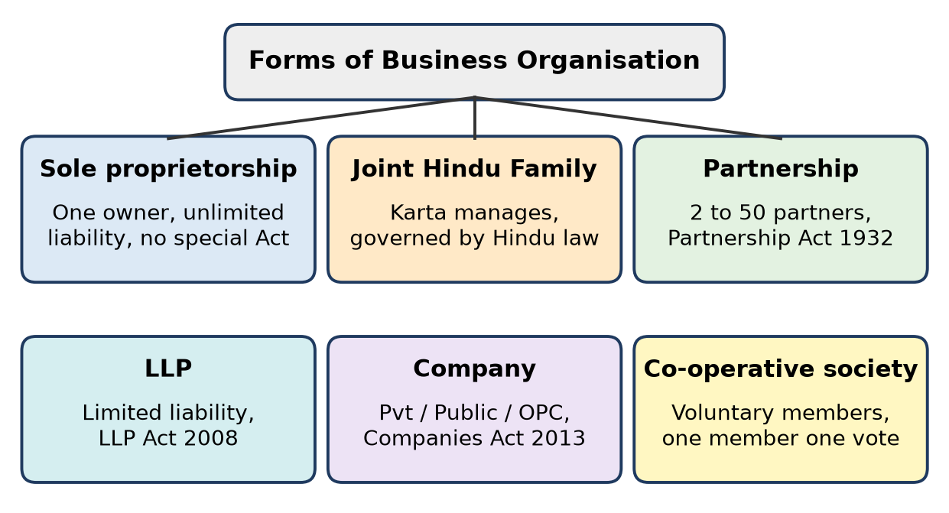
Figure: Forms of business organisation
Key idea: the form depends on ownership, liability and control – one owner (sole), agreed partners (partnership/LLP), members (co-operative), shareholders (company), brand licence (franchise).
Remember: One = Sole, Two+ = Partnership, Limited partners = LLP, Members = Co-op, Shareholders = Company.

Q4. Compare Partnership and Limited Liability Partnership (LLP) with respect to ownership, liability and management.
4 Marks • L2 Understand • CO3
Basis | Partnership | LLP
Law | Indian Partnership Act, 1932 | LLP Act, 2008
Ownership | Partners, 2 to 50 | Partners, minimum 2, no maximum
Legal status | Not a separate legal entity | Separate legal entity (body corporate)
Liability | Unlimited, joint and several – personal assets at risk | Limited to agreed contribution
Management | All partners manage; each is an agent of the firm and other partners | Managed as per LLP agreement; at least 2 designated partners (one resident in India) handle compliance
Registration | Optional (Registrar of Firms) | Compulsory (MCA)
Continuity | May dissolve on death / exit of a partner | Perpetual succession
Compliance | Very low | Annual filings with MCA

Conclusion: LLP gives the flexibility of a partnership with the limited liability of a company.
Remember: LLP = Partnership + Limited liability + Separate entity.

Q5. A restaurant owner operates an independent restaurant, while another entrepreneur operates an outlet using the brand name, standard processes and support of an established restaurant chain. Contrast the two business arrangements.
5 Marks • L2 Understand • CO3
The first is an independent business; the second is a franchise (franchisee of a restaurant chain).
Basis | Independent restaurant | Franchise outlet
Brand | Own new brand – must build recognition | Established brand – instant recognition
Control | Full freedom on menu, price, décor | Must follow franchisor's menu, SOPs, design
Start-up cost | Lower fees but more trial and error | Franchise fee + set-up as per standards
Ongoing payment | None to others | Royalty (share of sales) and marketing fee
Support | No outside support | Training, supply chain, marketing, technology
Risk | Higher – unproven concept | Lower – tested model
Profit | Keeps all profit | Shares part through royalty
Innovation | High freedom to innovate | Limited – must stay uniform
Legal basis | Business registration, FSSAI, GST | Same + franchise agreement (Contract Act 1872) and trademark licence

Conclusion: Independent = freedom with higher risk; franchise = support and safety with less freedom.
Remember: Independent: "my way, my risk". Franchise: "their way, shared risk".

Q6. A well-known restaurant brand allows an independent entrepreneur to use its brand name, products, operating procedures and marketing system in return for agreed payments. Interpret the business arrangement and examine the relationship between the two parties.
5 Marks • L3 Apply • CO3
This is franchising (business-format franchise). The brand owner is the franchisor; the entrepreneur is the franchisee.
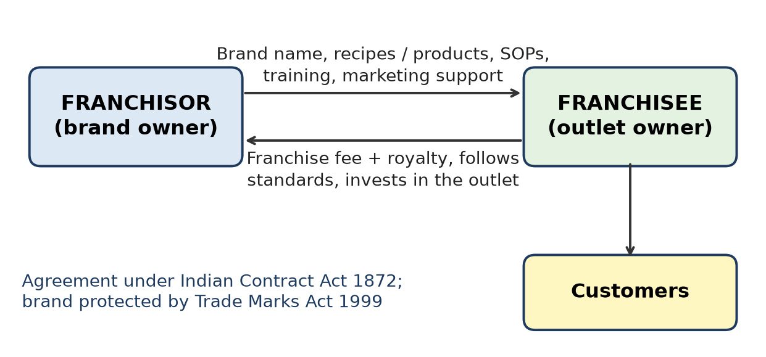
Figure: Franchisor–franchisee relationship
Relationship:
1. Contractual – based on a franchise agreement under the Indian Contract Act, 1872 (term, territory, fees, standards, exit). India has no separate franchise law.
2. Franchisor gives: brand and trademark licence (Trade Marks Act 1999), recipes / products, SOPs, training, supply chain, national advertising.
3. Franchisee gives: initial franchise fee, ongoing royalty (percentage of sales), investment in the outlet, staff, and strict adherence to standards.
4. Independent ownership – franchisee owns and runs the outlet, bears local business risk, keeps profit after royalty.
5. Control and inspection – franchisor audits quality to protect brand image.
6. Mutual benefit – franchisor expands fast with less capital; franchisee gets a proven model.
Risks: disputes over fees, territory, poor performance; one bad outlet can hurt the whole brand.
Example: McDonald's, Subway and Haldiram's franchise outlets.
Remember: Franchise = "Rent a brand, follow the rules, pay a royalty".

Q7. Amul and Mother Dairy both operate in the dairy sector but have different organizational backgrounds and structures. Summarize the organizational characteristics that distinguish the two businesses.
5 Marks • L2 Understand • CO3
Basis | Amul | Mother Dairy
Form | Co-operative – farmer-owned | Company – wholly owned subsidiary of the National Dairy Development Board (NDDB)
Origin | Kaira District Co-operative Milk Producers' Union, Anand, 1946; built by Verghese Kurien | Set up in 1974 under Operation Flood
Ownership | Lakhs of milk-producer members | NDDB (a statutory body under the Government of India)
Structure | Three-tier: village society → district union → state federation (GCMMF markets the Amul brand) | Corporate structure with a board and professional management
Control | Democratic – one member, one vote; elected boards | Board of directors appointed by the owner
Profit use | Returned to farmers as better milk prices and bonus | Retained or reinvested as per company decisions
Law | Co-operative Societies Acts | Companies Act
Brands | Amul | Mother Dairy, Safal

Conclusion: Amul is owned by its suppliers (farmers); Mother Dairy is a company owned by a public institution – both strengthened India's dairy sector.
Remember: Amul = farmers own it; Mother Dairy = NDDB owns it.

Q8. Dabur India Limited has a long history as a family-founded business but operates today as a professionally managed listed company with a formal corporate structure. Relate its present organizational structure with the characteristics of a Joint Hindu Family Business.
5 Marks • L4 Analyse • CO3
Background: Dabur was founded in 1884 by Dr S. K. Burman in Kolkata; the Burman family remain major promoters, but the company is listed and run by professional managers with a board.
Joint Hindu Family (JHF) Business – features: run by the Karta (eldest member), members (coparceners) join by birth, governed by Hindu law, Karta has unlimited liability while others' liability is limited to their share, continues after a member's death.
Basis | JHF business | Dabur India Ltd today
Governing law | Hindu law | Companies Act 2013, SEBI rules
Membership | By birth in the family | By buying shares – anyone
Management | Karta alone | Board of directors + professional CEO
Liability | Karta unlimited | Limited for all shareholders
Legal status | Not separate from family | Separate legal entity
Disclosure | Private | Public results, audits, governance reports
Continuity | Through family line | Perpetual succession

Link / what remains: family values, long-term outlook and family representation on the board – family ownership with professional management.
Remember: Dabur moved from Karta-control to Board-control, keeping family values.

Q9. Haldiram's has expanded through a combination of company-operated businesses and franchise arrangements. Break down the role of the brand owner and franchise operator in such an arrangement.
7 Marks • L4 Analyse • CO3
Situation: Haldiram's, a family-founded snacks and sweets brand (started in Bikaner, 1937), runs its own (company-operated) outlets and also gives franchises. This dual model gives control in key locations and fast growth elsewhere.
Figure: Franchisor–franchisee relationship
Role of brand owner (franchisor):
1. Brand and trademark – owns and protects the name, logo and recipes (Trade Marks Act 1999).
2. Product supply – centralised manufacturing ensures same taste everywhere.
3. Standards and SOPs – store design, hygiene, menu, pricing.
4. Training – staff and manager training.
5. Marketing – national advertising and promotions.
6. Site approval and audits – checks quality, can terminate for violations.
7. Earns franchise fee + royalty; uses own outlets as models.
Role of franchise operator (franchisee):
1. Invests capital – premises, interiors, equipment, working capital.
2. Runs daily operations – staff, sales, cash, local promotion.
3. Follows standards strictly; buys products from approved sources.
4. Local compliance – FSSAI licence, GST, Shops Act, labour laws.
5. Pays fees and shares sales data.
6. Bears local risk and keeps the remaining profit.
Aspect | Brand owner | Franchise operator
Owns | Brand, recipes, system | Outlet and its assets
Risk | Brand reputation | Local business risk
Income | Fee + royalty + product sales | Outlet profit

Conclusion: The brand owner provides the "what and how"; the operator provides "money and effort" – both gain from one trusted brand.
Remember: Brand owner = recipe + rules; Franchisee = rupees + running.

Q10. A student makes the following observations about Infosys: It has a formal Board of Directors. Responsibilities are assigned through a structured governance system. Information is disclosed to stakeholders. Major decisions are subject to accountability mechanisms. One of the following interpretations is incorrect: A. These practices are associated with corporate governance. B. These practices support transparency and accountability. C. These practices indicate that Infosys is a sole proprietorship. D. These practices protect stakeholder interests. Select the incorrect interpretation and explain the correction.
7 Marks • L4 Analyse • CO3
Incorrect interpretation: C.
Correction: Infosys is a public limited company (listed on Indian stock exchanges and NYSE), governed by the Companies Act 2013 and SEBI (LODR) Regulations 2015. A sole proprietorship has a single owner, no board, no legal duty to disclose information to the public and no separate legal entity – the opposite of what is observed.
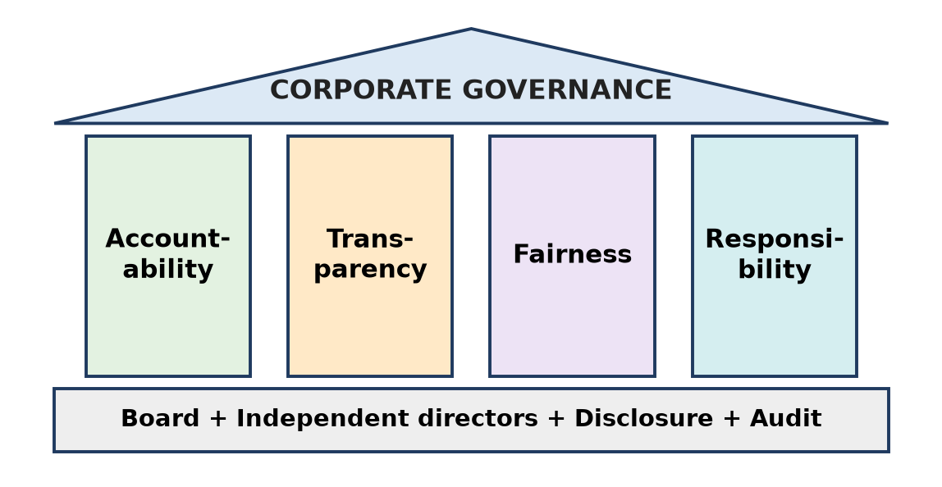
Figure: Pillars of corporate governance
Why A, B and D are correct – corporate governance: Corporate governance is the system of rules and practices by which a company is directed and controlled in the interest of all stakeholders.
1. Board of Directors – includes independent directors (listed companies need at least one-third independent directors).
2. Committees – audit, nomination and remuneration, stakeholders' relationship, CSR.
3. Transparency – quarterly results, annual reports, governance reports.
4. Accountability – auditors, shareholder voting, regulatory oversight.
5. Stakeholder protection – shareholders, employees, customers, lenders.
Feature | Sole proprietorship | Infosys (public company)
Owners | One | Lakhs of shareholders
Board | None | Formal board with independent directors
Disclosure | Not required | Mandatory
Liability | Unlimited | Limited

Infosys is often cited for its early adoption of high governance and disclosure standards.
Conclusion: The observations describe good corporate governance in a public company, not a sole proprietorship.
Remember: Board + Disclosure + Accountability = Company, never a sole proprietor.

Topic 2: Laws in India to Start Business

Q11. A group of engineering graduates wants to establish a new company in India. Arrange the following activities in a logical sequence for starting the business: Obtain required registrations and licences; Develop the business idea; Select the appropriate form of business; Register the business; Comply with applicable tax and labour requirements.
3 Marks • L2 Understand • CO3
Correct sequence:
1. Develop the business idea – problem, product, market.
2. Select the appropriate form of business – e.g. Private Limited Company (for funding and limited liability).
3. Register the business – incorporate with the Ministry of Corporate Affairs (SPICe+ form) under the Companies Act 2013.
4. Obtain required registrations and licences – PAN, TAN, GST, Udyam, Shops Act, sector licences (FSSAI, pollution consent etc.).
5. Comply with applicable tax and labour requirements – GST returns, income tax, EPF, ESI, annual filings – an ongoing activity.
Remember: Idea → Form → Register → Licence → Comply ("I-F-R-L-C").

Q12. Business: RSM India; Structure: LLP; Activity: Professional services; Partners: Multiple; Liability: Limited according to LLP framework. Interpret the information and associate the business structure with the appropriate Indian legislation.
3 Marks • L2 Understand • CO3
Legislation: Limited Liability Partnership Act, 2008, administered by the Ministry of Corporate Affairs (MCA).
Interpretation:
1. LLP – a hybrid of partnership and company; a separate legal entity.
2. Professional services (audit, tax, consulting) – LLP is popular with such firms.
3. Multiple partners – minimum 2, no upper limit; at least 2 designated partners.
4. Limited liability – each partner's liability is limited to the agreed contribution; a partner is not liable for another partner's misconduct.
5. Rights and duties are set by the LLP agreement filed with the MCA; annual statements must be filed.
Remember: Professional firm + many partners + limited liability = LLP Act 2008.

Q13. Three engineering graduates decide to establish a healthcare startup. They have selected their business structure and arranged initial finance, but they have not yet completed the formal registration or obtained the applicable permissions. Interpret the situation and outline the legal steps that should be addressed before commencing business operations.
4 Marks • L4 Analyse • CO3
Interpretation: Structure and money are ready, but the startup cannot legally operate until it is registered and licensed. Healthcare is a highly regulated sector.
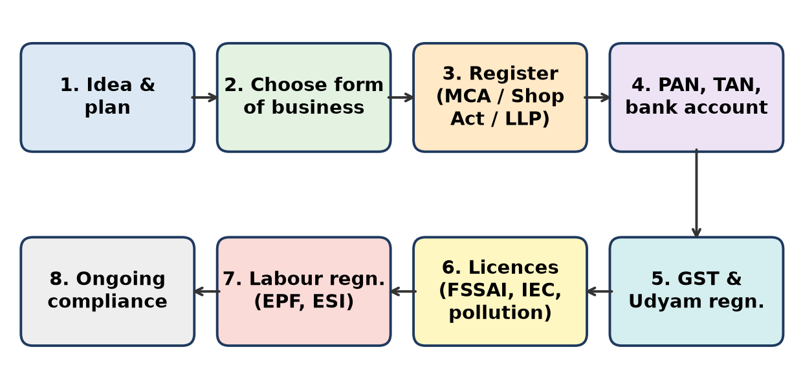
Figure: Legal steps to start a business in India
Legal steps before starting:
1. Incorporation – register the company / LLP with MCA (SPICe+ / FiLLiP); get Certificate of Incorporation; obtain PAN and TAN; open a bank account.
2. Tax registrations – GST (if applicable; many healthcare services are exempt), professional tax.
3. Local licences – Shops and Establishments registration, trade licence from the municipal body.
4. Healthcare-specific permissions –
- registration of clinic / diagnostic centre under the applicable state law (e.g. Clinical Establishments Act 2010, where adopted);
- doctors registered with the medical council;
- drug licence if running a pharmacy (Drugs and Cosmetics Act 1940); licence under Medical Devices Rules 2017 if making devices;
- Bio-medical Waste authorisation from the State Pollution Control Board.
5. Data protection – patient data handled as per the Digital Personal Data Protection Act 2023 and IT Act 2000.
6. Optional benefits – DPIIT (Startup India) recognition, Udyam registration.
7. Employment registrations – EPF / ESI when staff thresholds are reached.
Remember: Register → Tax → Local licence → Health licence → Data safety → then open doors.

Q14. A neighbourhood kirana business is operated and controlled by a single proprietor, while Flipkart Private Limited was incorporated as a private limited company. Examine the legal formalities involved in establishing these two forms of business in India.
4 Marks • L3 Apply • CO3
Basis | Kirana (sole proprietorship) | Private limited company (e.g. Flipkart)
Governing law | No separate Act | Companies Act 2013
Registration of the business | Not required as an entity | Compulsory incorporation with MCA / Registrar of Companies
Main documents | PAN of owner, address proof, bank account | DSC, DIN, name approval, MoA & AoA, SPICe+ form → Certificate of Incorporation (CIN)
Members / directors | One owner | Minimum 2 members (max 200) and 2 directors
Licences | Shops & Establishments registration, municipal trade licence, FSSAI registration for food items, Legal Metrology stamping of weighing scales | All relevant licences + GST, Shops Act for offices, sector rules (e-commerce rules)
GST | Only if turnover crosses threshold (₹40 lakh for goods in most states) | Usually compulsory (e-commerce operators must register)
Ongoing compliance | Income-tax return | Board meetings, statutory audit, annual filings with ROC, income tax, GST
Time and cost | Very quick and cheap | More time, cost and paperwork

Conclusion: The kirana needs only licences; the company needs incorporation plus continuous compliance, but gets limited liability and easier funding.
Remember: Kirana = licence and start; Pvt Ltd = incorporate, then comply forever.

Q15. During an FDA inspection on 19 August 2026, the Bombay Presidency Radio Club recorded a 47% non-compliance rate, following which its food business licence was suspended and it was ordered to stop the purchase, sale and distribution of food during the suspension period. Relate the importance of obtaining and maintaining the required licences while operating a food business.
5 Marks • L4 Analyse • CO3
Situation: A well-known club failed an FDA hygiene inspection (47% non-compliance); its food licence was suspended and all food activity had to stop.
Law involved: Food Safety and Standards Act, 2006 – every food business operator needs an FSSAI registration or licence and must follow hygiene and sanitary requirements; Food Safety Officers inspect, and licences can be suspended or cancelled for non-compliance.
Importance of obtaining and maintaining licences:
1. Legal right to operate – without a valid licence, food cannot be sold.
2. Business continuity – suspension means zero revenue while costs (rent, salaries) continue.
3. Customer safety – hygiene rules prevent food poisoning and health risks.
4. Reputation – news of suspension damages trust, even for a famous brand.
5. Avoid penalties – fines, prosecution and closure.
6. Maintaining is as important as obtaining – licences need renewal, and standards must be followed every day, not only at the time of application.
Lessons for a food entrepreneur: appoint a trained food-safety supervisor, maintain cleaning and pest-control records, do internal audits, train staff, act quickly on improvement notices.
Remember: Licence is not a one-time certificate; it is a daily promise of hygiene.

Q16. Relate the following Indian enterprises with the legal requirement most directly relevant to the stated activity: (Amul – food processing; RSM India – LLP structure; Tata International – import/export; Infosys – corporate structure; Tata Steel – manufacturing; Sun Pharma – pharmaceutical manufacturing; Flipkart – e-commerce; Mother Dairy – dairy products)
5 Marks • L4 Analyse • CO3
Enterprise / Activity | Most relevant legal requirement
1. Amul – food processing | FSSAI licence under Food Safety and Standards Act 2006
2. RSM India – LLP structure | LLP Act 2008 (registration with MCA)
3. Tata International – import/export | Importer Exporter Code (IEC) from DGFT; Customs Act 1962; Foreign Trade (Development and Regulation) Act 1992; FEMA 1999
4. Infosys – corporate structure | Companies Act 2013 and SEBI (LODR) Regulations for listed companies
5. Tata Steel – manufacturing | Factory licence and safety laws (now under the OSH Labour Code) + pollution consents (Air Act 1981, Water Act 1974, Environment Protection Act 1986)
6. Sun Pharma – pharma manufacturing | Drug manufacturing licence under Drugs and Cosmetics Act 1940 (CDSCO / State drug controller); Patents Act 1970
7. Flipkart – e-commerce | Consumer Protection (E-Commerce) Rules 2020, IT Act 2000, GST rules for e-commerce operators (TCS), FDI policy for marketplaces
8. Mother Dairy – dairy products | FSSAI licence (milk and milk-product standards)

Remember: Food = FSSAI, Trade = IEC, Company = Companies Act, LLP = LLP Act, Drugs = D&C Act, Online = E-commerce Rules.

Q17. The Maharashtra FDA and Pune Rural Police recently busted an inter-district synthetic milk racket, with raids conducted at locations including Manchar, Akluj, Ahilyanagar, Sillod and Sangli. Thirteen people were arrested and materials worth more than ₹2 crore were seized. Analyse the legal and business-compliance failures represented in this case and explain the risks they create for a food entrepreneur.
5 Marks • L4 Analyse • CO3
Situation: A network made and sold synthetic (fake) milk across districts; 13 arrests, ₹2 crore+ material seized.
Legal and compliance failures:
1. Adulteration / unsafe food – selling synthetic milk violates the Food Safety and Standards Act 2006 (unsafe, sub-standard and misbranded food) and criminal laws against food adulteration.
2. No valid licence / misuse of licence – production outside licensed, inspected premises.
3. No quality testing – no lab testing of milk as per FSSAI standards.
4. Supply-chain failure – buyers (dairies, sweet shops) did not verify sources.
5. Fraud on consumers – misleading customers; also a consumer-protection offence.
6. Possible tax evasion – unrecorded, cash-based trade.
Risks for a food entrepreneur:
Risk | Effect
Legal | Arrest, imprisonment, heavy fines, seizure of stock
Licence | Suspension or cancellation – business stops
Health | Customers may fall ill – liability claims
Reputation | Loss of trust; even honest sellers in the area suffer
Supply chain | Buying from a bad supplier can make you liable

Precautions: buy only from licensed suppliers, test raw milk regularly, keep batch records, train staff, follow FSSAI labelling.
Conclusion: In food business, compliance is survival – shortcuts can end the business and endanger lives.
Remember: Adulteration = crime, not a cost-saving trick.

Q18. Consider Tata Motors and Tata International. Both are part of the Tata business group, but their activities involve different operational requirements. Contrast the additional legal considerations that may arise for an automobile manufacturer and an enterprise engaged in international trade.
5 Marks • L2 Understand • CO3
Basis | Automobile manufacturer (Tata Motors) | International trading enterprise (Tata International)
Product approval | Vehicle type approval / homologation under Central Motor Vehicles Rules 1989 (testing by agencies like ARAI) | Product standards of importing countries; BIS quality-control orders for some imports
Emissions and safety | Bharat Stage (BS-VI) emission norms, crash and safety standards | Not directly – depends on goods traded
Factory and labour | Factory licence, worker safety, wages, social security (Labour Codes) | Mostly office staff – Shops and Establishments law
Environment | Pollution consents (Air, Water, Environment Protection Acts), hazardous waste rules | Limited – mainly packaging / port rules
Trade licences | Import of components through customs | IEC (DGFT), Customs Act 1962, Foreign Trade Policy, licences for restricted items
Foreign exchange | Payments for imported parts | FEMA 1999 – receive export proceeds and pay for imports through banks within set time limits
Taxes | GST on vehicles and components | Customs duty on imports, GST zero-rated exports, export incentives
Consumer liability | Product liability and recalls (Consumer Protection Act 2019) | Contract and trade disputes, international contract law, letters of credit
Foreign laws | Mainly Indian rules (exports need foreign approvals) | Laws, sanctions and anti-dumping rules of many countries

Conclusion: A manufacturer faces product, factory and environmental laws; a trader faces customs, foreign-trade and foreign-exchange laws.
Remember: Maker: "Is the product safe and clean?" Trader: "Is the shipment legal across borders?"

Q19. A software startup initially operates as a small LLP providing domestic services. It later begins importing computer hardware and expands its workforce substantially. Explain how the legal requirements applicable to the enterprise may change as its activities expand.
7 Marks • L2 Understand • CO3
Stage 1 – small domestic LLP: LLP Act 2008 (annual filings), PAN, bank account, GST if turnover crosses the threshold, Shops and Establishments registration, income tax.
Stage 2 – after expansion, new requirements arise:
A. Importing hardware
1. Importer Exporter Code (IEC) from DGFT – needed for any import.
2. Customs Act 1962 – customs duty, bill of entry, valuation; IGST on imports.
3. BIS compulsory registration for many electronic and IT products sold in India.
4. FEMA 1999 – foreign payments through authorised banks.
5. E-waste Management Rules – if it sells hardware, it may have EPR duties.
B. Larger workforce
1. EPF registration (from 20 employees) and ESI registration (from 10 employees in notified areas) – now under the Code on Social Security.
2. Wages, working hours, leave – Code on Wages and state Shops and Establishments law.
3. Gratuity and bonus obligations.
4. POSH Act 2013 – Internal Committee against sexual harassment (10+ employees).
5. TDS on salaries; professional tax (e.g. Maharashtra).
6. Standing orders / service rules as headcount grows (Industrial Relations Code).
C. Business-level changes
1. Higher turnover → GST registration compulsory, possibly e-invoicing; tax audit; LLP accounts audit once turnover or contribution crosses the LLP Act limits.
2. Data protection – DPDP Act 2023 for customer and employee data.
3. May convert to a Private Limited Company to raise venture capital (LLPs cannot issue shares).
Conclusion: As the enterprise grows, its compliance moves from "register and file" to trade, labour, tax and data compliance – planning for this avoids penalties.
Remember: Grow in size = grow in compliance (Import → IEC; People → EPF/ESI/POSH; Turnover → GST/audit).

Q20. In June 2026, an environmental regulator accused a Tata Electronics facility in Hosur of groundwater contamination linked to wastewater discharge. Tata stated that an independent analysis found the facility compliant. Interpret the case from the perspective of an entrepreneur planning to establish a manufacturing facility and explain the importance of environmental compliance before and during business operations.
7 Marks • L2 Understand • CO3
Interpretation: Even a large, reputed group can face regulatory action and public criticism over pollution. The dispute (regulator's allegation vs company's independent analysis) shows that a manufacturer must be able to prove compliance with data at all times.
Key environmental laws in India:
- Water (Prevention and Control of Pollution) Act 1974
- Air (Prevention and Control of Pollution) Act 1981
- Environment (Protection) Act 1986, EIA Notification 2006
- Hazardous and Other Wastes Rules 2016; E-waste rules; groundwater rules (CGWA)
Before operations (planning stage):
1. Consent to Establish (CTE) from the State Pollution Control Board.
2. Environmental Impact Assessment (EIA) and clearance, if the project category requires it.
3. Site selection – away from sensitive water bodies; check groundwater rules.
4. Design treatment systems – Effluent Treatment Plant (ETP), zero liquid discharge where required.
During operations:
1. Consent to Operate (CTO) – renewed periodically.
2. Regular monitoring of effluent, air emissions and groundwater; keep lab reports.
3. Proper hazardous-waste handling and authorised disposal.
4. Third-party audits and transparent reporting.
5. Quick corrective action on any complaint.
Why it matters:
Benefit | Explanation
Legal | Avoid closure orders, fines, prosecution, NGT cases
Financial | Prevent costly shutdowns and clean-up
Reputation | Customers, investors and communities trust a clean company
Social | Protects health and water of nearby people

Conclusion: For a new manufacturer, environmental compliance is not a cost but insurance for survival – build it in from day one.
Remember: Before: CTE + EIA; During: CTO + monitor + record.

Topic 3: Legal Aspects of Business (IPR, GST, Labour Laws)

Q21. Amul has built strong recognition around its brand name, logo and distinctive identity. Explain why protecting such brand elements is important for an established business.
3 Marks • L2 Understand • CO3
Brand name, logo and identity are protected as trademarks under the Trade Marks Act, 1999 (registration valid 10 years, renewable forever).
Importance:
1. Stops copying – others cannot sell look-alike products under a similar name.
2. Customer trust – buyers know they are getting genuine quality.
3. Valuable asset – a strong brand adds huge value to the business.
4. Legal action – owner can sue for infringement and passing off.
5. Supports expansion – licensing, franchising and new products under the same brand.
Amul's name is widely recognised and Amul has taken legal action against misuse of its brand.
Remember: Brand = reputation; trademark = its lock.

Q22. Business A: A manufacturer sells goods directly to customers. Business B: An online marketplace facilitates sales between sellers and customers. Contrast the GST-related business considerations that may arise in the two situations.
3 Marks • L2 Understand • CO3
Basis | Business A – Manufacturer | Business B – Online marketplace
Registration | Needed if turnover crosses threshold (₹40 lakh for goods in most states) | Compulsory, irrespective of turnover (e-commerce operator)
Tax charged | GST on its own sales | Collects TCS (Tax Collected at Source) on sales made by sellers on its platform
Input Tax Credit | Claims ITC on raw materials | Claims ITC on its own services (commission, ads)
Returns | GSTR-1, GSTR-3B | Also files GSTR-8 (TCS return)
Special rules | E-way bills for moving goods, e-invoicing above turnover limit | For some services (e.g. restaurant food delivery) the operator itself pays GST

Remember: Manufacturer pays GST on its sales; marketplace also collects TCS for sellers' sales.

Q23. Relate each of the following real-life examples with the appropriate IPR category: (Tata Motors' "TATA" brand name and logo; a patented technological invention developed by CSIR laboratories; the original source code of an Indian software product such as Zoho's software; Darjeeling Tea's protected identity based on its geographical origin; the distinctive "Amul" name and logo used on dairy products; a newly developed drug formulation by an Indian pharmaceutical company; the distinctive design of a commercially manufactured product registered by its creator; Banarasi Saree, whose identity is linked to its traditional geographical region)
4 Marks • L4 Analyse • CO3
Real-life example | IPR category
"TATA" brand name and logo | Trademark (Trade Marks Act 1999)
CSIR patented invention | Patent (Patents Act 1970)
Zoho's original source code | Copyright – software is a literary work (Copyright Act 1957)
Darjeeling Tea | Geographical Indication (GI) – India's first GI
"Amul" name and logo | Trademark
New drug formulation | Patent (if new, inventive and industrially useful)
Registered distinctive product design | Industrial Design (Designs Act 2000)
Banarasi Saree | Geographical Indication (GI)

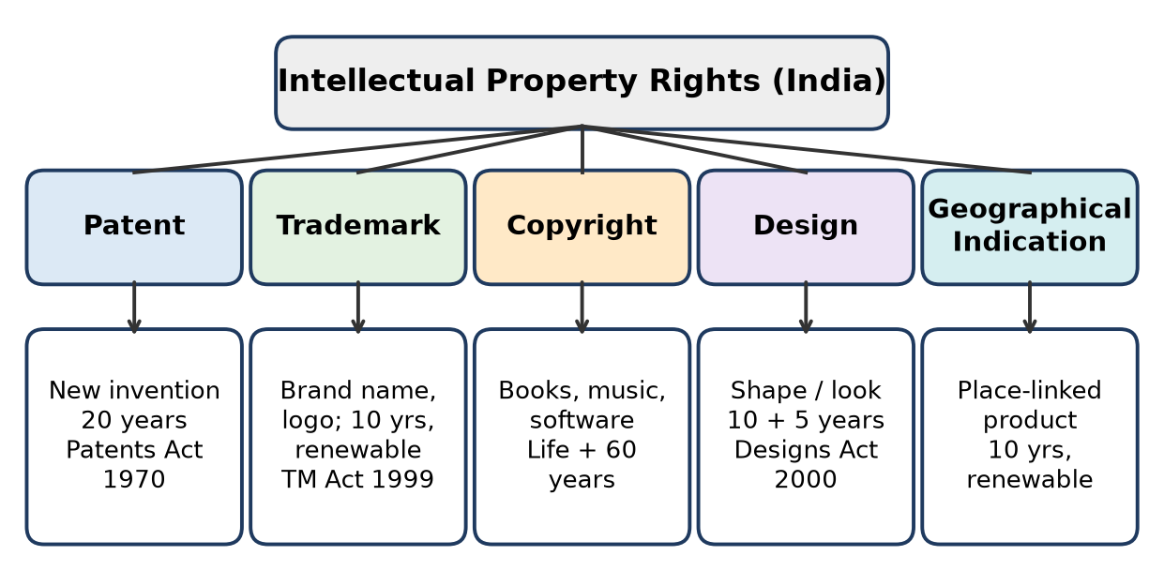
Figure: Types of IPR in India
Remember: Name/logo = TM, Invention = Patent, Code = Copyright, Look = Design, Place = GI.

Q24. "My company has registered its trademark, so competitors cannot copy my newly developed machine." Restate the statement correctly by distinguishing protection of a brand from protection of an invention.
4 Marks • L2 Understand • CO3
Correct statement: "My company has registered its trademark, so competitors cannot use my brand name or logo. To stop them from copying my newly developed machine, I must obtain a patent on the invention (and may register its appearance as a design)."
Basis | Trademark | Patent
Protects | Brand name, logo, symbol – identity | New invention – technical idea / working
Law | Trade Marks Act 1999 | Patents Act 1970
Test | Distinctive, not confusing | New, inventive step, industrial use
Term | 10 years, renewable forever | 20 years from filing, not renewable
Stops others from | Selling under a similar name | Making, using, selling the invention

Explanation: A trademark only stops confusion about the source; a competitor could still make an identical machine under a different brand unless the machine is patented.
Remember: Trademark guards the NAME; patent guards the MACHINE.

Q25. A pharmaceutical company develops a new drug → ______; It gives the medicine a distinctive brand name → ______; It employs workers in its manufacturing facility → ______; It sells the medicine subject to applicable indirect-tax requirements → ______. Relate the legal framework associated with each activity.
4 Marks • L4 Analyse • CO3
Activity | Legal framework
Develops a new drug | Patent – Patents Act 1970 (20 years); plus drug approval under Drugs and Cosmetics Act 1940 / New Drugs and Clinical Trials Rules 2019
Gives a distinctive brand name | Trademark – Trade Marks Act 1999
Employs workers in the factory | Labour laws – the Labour Codes on wages, social security (EPF, ESI), industrial relations and occupational safety (earlier Factories Act 1948)
Sells subject to indirect tax | GST – CGST / SGST / IGST Acts 2017

Explanation: One business activity chain touches IPR, product regulation, labour law and tax law – an entrepreneur must plan for all.
Remember: Invent → Patent, Name → Trademark, Workers → Labour Codes, Sell → GST.

Q26. A company owns a patent, a trademark and copyrighted software. Differentiate the three assets based on the nature of what each form of IPR protects.
5 Marks • L2 Understand • CO3
Figure: Types of IPR in India
Basis | Patent | Trademark | Copyright (software)
What it protects | A new invention – product or process | Brand identity – name, logo, symbol, tagline | Original expression – code, books, music, films
Nature | Functional / technical idea | Commercial identity, source of goods | Creative expression (not the idea itself)
Law (India) | Patents Act 1970 | Trade Marks Act 1999 | Copyright Act 1957
Requirement | Novelty, inventive step, industrial use; must be applied for and granted | Distinctive mark; registration gives strong rights | Arises automatically on creation; registration optional
Term | 20 years | 10 years, renewable indefinitely | Author's life + 60 years (for literary works such as software)
Example | New engine-cooling system | "Amul" logo | Source code of an accounting app

Note: In India, a computer program "per se" is not patentable; software is mainly protected by copyright.
Conclusion: Patent protects how it works, trademark protects who made it, copyright protects how it is expressed.
Remember: Patent = invention, Trademark = identity, Copyright = expression.

Q27. A Pune-based engineering startup develops a unique braking mechanism and sells it under the brand name "Safestop." Interpret the two different intellectual-property aspects represented by the invention and the brand name.
5 Marks • L2 Understand • CO3
1. The braking mechanism → Patent (Patents Act 1970)
- It is a technical invention; if it is new, involves an inventive step and is industrially applicable, it can be patented.
- Gives the startup the exclusive right to make, use and sell it for 20 years.
- Must be filed before public disclosure; a provisional application can secure an early filing date.
- Startups get fee concessions and fast-track examination.
2. The brand name "Safestop" → Trademark (Trade Marks Act 1999)
- Identifies the startup as the source of the product.
- Registration (10 years, renewable) stops others from using the same or a confusingly similar name.
- The ™ symbol can be used once applied; ® only after registration.
Aspect | Invention | "Safestop"
IPR type | Patent | Trademark
Protects | How the brake works | Brand identity
Term | 20 years | 10 years, renewable

Conclusion: The startup needs both: the patent protects its technology, the trademark protects its market identity.
Remember: Safestop: patent the brake, trademark the name.

Q28. In February 2026, a tax investigation into the restaurant sector reported alleged manipulation of billing software to suppress sales, including instances where recorded bills were allegedly reduced substantially. Outline the legal responsibility of a business regarding sales records and tax compliance in light of the above case.
5 Marks • L4 Analyse • CO3
Situation: Restaurants allegedly altered billing software to show lower sales and pay less tax – this is tax evasion, not a business strategy.
Legal responsibilities of a business:
1. Issue proper invoices for every sale (CGST Act, Sec 31).
2. Maintain true and complete accounts of sales, purchases, stock and tax (Sec 35) and preserve records for the period required by law (generally 72 months).
3. Report sales correctly in GST returns (GSTR-1, GSTR-3B) and pay the right tax on time.
4. Use honest billing systems – never delete, edit or hide bills; e-invoicing where applicable.
5. Income-tax compliance – report true income; suppressed sales lead to penalties for under-reported income.
6. Allow inspection and audit by tax authorities.
Consequences of manipulation:
- Demand of unpaid tax with interest and penalty.
- Prosecution and imprisonment for large evasion (CGST Act, Sec 132).
- Seizure of records, bank attachment, loss of reputation.
- Software vendors who help can also be liable.
Lesson for entrepreneurs: Accurate records protect the business, build lender and investor trust, and allow genuine input tax credit.
Remember: Every bill counts: record it, report it, pay on it.

Q29. On 18 August 2026, Mumbai Police raided a garment manufacturing unit at Charkop Industrial Estate and rescued 13 boys aged 13–16 who were allegedly being employed as child labourers. Analyse the legal responsibility of a business owner while recruiting workers for a manufacturing enterprise.
7 Marks • L4 Analyse • CO3
Situation: A garment unit allegedly employed 13 boys aged 13–16.
Relevant laws:
1. Child and Adolescent Labour (Prohibition and Regulation) Act, 1986 (amended 2016)
- Children below 14 – cannot be employed in any occupation or process (narrow family / artist exceptions only).
- Adolescents (14–18) – cannot be employed in hazardous occupations or processes; where allowed, working hours and conditions are restricted.
- Employer penalty: imprisonment of 6 months to 2 years and/or fine of ₹20,000 to ₹50,000; higher for repeat offences.
2. Juvenile Justice (Care and Protection of Children) Act, 2015 – exploiting a child for employment is a punishable offence.
3. Labour Codes / factory laws – minimum age, registers, safety, working hours.
4. Constitution – Article 24 bans employing children below 14 in factories, mines and hazardous work.
Legal responsibilities while recruiting:
1. Verify age – Aadhaar, birth or school certificate; keep copies.
2. Never hire below 14; for 14–18, check that the work is non-hazardous and follow hour limits.
3. Maintain registers of workers with age, wages and hours.
4. Control contractors – the principal employer must ensure contractors also follow the law.
5. Pay minimum wages, provide safety, EPF / ESI.
6. Train supervisors and conduct internal audits.
Business risks of violation:
Risk | Effect
Legal | Arrest, imprisonment, fines, sealing of unit
Market | Brands and export buyers cancel orders (ethical sourcing)
Reputation | Public and media backlash

Conclusion: Responsible recruitment is a legal duty and an ethical duty – no profit justifies child labour.
Remember: Check age, keep records, control contractors – "No child on the shop floor".

Q30. On 12 July 2026, a raid on factories in Ludhiana resulted in the rescue of 19 minors allegedly employed as workers. Cases were registered against the factory owners under child-labour and juvenile-justice provisions. A business may be legally established as an enterprise but still violate laws through its employment practices. Break down this distinction using the July 2026 Ludhiana case.
7 Marks • L4 Analyse • CO3
The distinction: Legal establishment (being properly registered) is different from legal operation (following all laws every day).
1. Legally established enterprise
- Registered as a firm or company, has PAN, GST, factory licence, Shops / Udyam registration.
- This proves the business exists legally – it is a one-time / periodic step.
2. Lawful employment practices (ongoing compliance)
- No child labour; age verification of every worker.
- Minimum wages, fixed working hours, overtime pay.
- Safety, social security (EPF / ESI), proper registers.
- These must be followed every day.
Applying to the Ludhiana case:
Aspect | Ludhiana factories
Establishment | Factories were operating as enterprises (presumably registered)
Practice | Allegedly employed 19 minors
Laws violated | Child and Adolescent Labour Act 1986, Juvenile Justice Act 2015
Result | Rescue of children, criminal cases against owners

Analysis:
1. Registration does not give immunity – liability arises from conduct.
2. The owner / occupier is personally responsible, even if a contractor hired the children.
3. Violations bring criminal consequences, not just fines.
4. Buyers and lenders look at labour practices, not only licences.
Conclusion: A business must be lawful in form (registration) and lawful in practice (employment) – the second failed in Ludhiana.
Remember: Registered ≠ Responsible: licence on the wall must match practice on the floor.

Quick Revision – Unit 3
Term | Key fact
Sole proprietorship | One owner, unlimited liability, no special Act
Joint Hindu Family business | Karta manages, membership by birth, Hindu law
Partnership | Indian Partnership Act 1932, 2–50 partners, unlimited liability, mutual agency
LLP | LLP Act 2008, separate entity, liability limited to contribution, min 2 designated partners
Private company | Companies Act 2013, 2–200 members, min 2 directors
Public company | Min 7 members, min 3 directors, can list shares
Co-operative | One member one vote (Amul)
Franchising | Franchisor gives brand and system; franchisee pays fee + royalty
Corporate governance | Accountability, transparency, fairness, responsibility; independent directors
Incorporation | MCA SPICe+ form, DSC, DIN, MoA, AoA → Certificate of Incorporation
FSSAI | Licence / registration for every food business (FSS Act 2006)
IEC | Importer Exporter Code from DGFT for import / export
Pollution consents | CTE before setting up, CTO before operating (Water 1974, Air 1981, EPA 1986)
IPR terms | Patent 20 yrs; Trademark 10 yrs renewable; Copyright life + 60; Design 10 + 5; GI 10 renewable
GST | E-commerce operator: compulsory registration and TCS
Child labour | No child below 14 in any work; 14–18 not in hazardous work (Act of 1986, amended 2016)

Unit 4: Case Studies on Business Failures

Topic 1: Concepts of Entrepreneurship Failure – Issues of Entrepreneurial Failure

Q1. A startup develops an innovative product, but very few customers are willing to purchase it. Use the concept of entrepreneurial failure to determine the issue represented by this situation.
3 Marks • L3 Apply • CO4
Entrepreneurial failure means a venture cannot meet its goals and has to close or be sold because it cannot survive financially.
Issue here: lack of market demand / no product–market fit.
1. The product is innovative but does not solve a problem customers care about enough to pay for.
2. Likely causes: no market research, no customer validation, wrong target customer, price too high, poor awareness.
3. "No market need" is one of the most common reasons startups fail.
Fix: talk to customers early, build an MVP, test willingness to pay, then pivot the product or market.
Remember: Innovation without customers = invention, not business.

Q2. An engineering startup has developed a technically successful product, but its production cost is much higher than the price customers are willing to pay. Apply the concept of entrepreneurial failure to demonstrate why technical success alone may not ensure business success.
3 Marks • L3 Apply • CO4
Issue: poor unit economics / commercial non-viability.
1. Business success needs Price > Cost per unit; here cost is higher, so every sale makes a loss.
2. Selling more only increases losses – the business cannot survive without endless funding.
3. Technical feasibility ≠ economic feasibility – engineers must also design for cost (cheaper materials, simpler design, scale).
Example: If cost = ₹12,000 and customers pay only ₹8,000, the loss is ₹4,000 per unit.
Fix: value engineering, target a premium customer segment, or change the business model (rent / service).
Remember: Works in the lab ≠ works in the market; margin matters.

Q3. PepperTap, an Indian grocery-delivery startup, shut down its operations in April 2016. Consider the following issues: A. Difficulty in achieving sustainable unit economics; B. Lack of product innovation; C. Intellectual-property infringement; D. Workplace safety. Apply the concept of entrepreneurial failure and select the issue most relevant to a hyperlocal delivery business such as PepperTap.
5 Marks • L3 Apply • CO4
Answer: A – Difficulty in achieving sustainable unit economics.
Why A is most relevant:
1. Unit economics = profit or loss on each order. In hyperlocal grocery delivery, each order has low value and thin margins.
2. High delivery cost – riders, fuel and time per order are high compared with the margin.
3. Heavy discounts were used to attract customers; when discounts stopped, customers left.
4. Cash burn – losses grow as orders grow; funding is needed constantly.
5. Strong competition from well-funded rivals (Grofers, BigBasket) pushed costs up further.
Why not the others:
- B – app-based grocery delivery was itself new; lack of innovation was not the main cause.
- C – no major IP dispute is linked to its closure.
- D – workplace safety is not the core issue for a delivery platform's survival.
Lesson: Before scaling, prove that each order is profitable (raise order value, cluster deliveries, cut discounts).
Remember: Growth with loss per order = faster failure.

Q4. Kingfisher Airlines ceased operations in October 2012 after prolonged financial and operational difficulties. Show one warning sign in this situation that an entrepreneur should recognize before a venture reaches the failure stage.
5 Marks • L3 Apply • CO4
Situation: Kingfisher Airlines (launched 2005 by Vijay Mallya's UB Group) never made a profit and stopped flying in October 2012 when its licence was suspended.
Key warning sign: continuous losses funded by rising debt, leading to unpaid dues and delayed salaries.
1. Losses year after year – costs (luxury service, fuel, aircraft leases) were far above revenue.
2. Rising borrowing – loans from a consortium of banks grew to thousands of crores.
3. Delayed salaries and unpaid dues – staff went unpaid for months; dues to oil companies, airports and tax authorities piled up.
4. Flight cancellations and grounded planes – a visible sign of cash shortage.
Why an entrepreneur should notice: When a business pays old debts with new loans and delays salaries, it is in a liquidity crisis – the last stage before collapse.
Action at that stage: cut costs, restructure debt, sell non-core assets, bring in equity, or change the model – early, not late.
Remember: Delayed salaries are the smoke; unpaid debt is the fire.

Q5. Jet Airways suspended operations in April 2019 amid severe financial difficulties. A new airline is planning to operate with heavy debt and high fixed costs. Illustrate one lesson from the Jet Airways experience that should be considered before launching the venture.
5 Marks • L3 Apply • CO4
Situation: Jet Airways, once a leading full-service airline (founded by Naresh Goyal), suspended operations on 17 April 2019 after running out of cash; it owed large sums to banks, lessors, vendors and employees.
Lesson: Do not run a high-fixed-cost, low-margin business on heavy debt without a strong cash buffer and a competitive cost structure.
1. Airlines have high fixed costs – aircraft leases, salaries, maintenance – that must be paid even when seats are empty.
2. Margins are thin and volatile – fuel prices, rupee value and fare wars change quickly.
3. Low-cost competitors (e.g. IndiGo) had lower costs per seat; Jet's full-service costs were higher.
4. Debt adds fixed interest – in a bad year, the airline cannot pay and lessors ground planes.
Application to the new airline:
- Keep debt low, raise more equity.
- Maintain cash reserves for several months of fixed costs.
- Lease aircraft flexibly; hedge fuel; keep costs per seat competitive.
- Monitor cash flow weekly.
Remember: High fixed cost + high debt + thin margin = crash risk.

Q6. Nokia lost significant smartphone market share during the early 2010s as the industry shifted rapidly toward smartphones and competing operating systems. A mobile-device startup is facing a similar technological shift. Modify its strategy to remain competitive.
5 Marks • L3 Apply • CO4
Situation: Nokia was the world's largest mobile-phone maker, but after the iPhone (2007) and Android (2008) it stayed with its ageing Symbian system, moved late to Windows Phone (2011), and sold its phone business to Microsoft (2014).
Lessons: slow response to technology change, focus on hardware while value moved to software and app ecosystems, internal resistance to change.
Modified strategy for the startup:
1. Technology scanning – track trends (AI, 5G, foldables) and customer shifts continuously.
2. Adopt the winning platform early – join the dominant ecosystem instead of fighting it.
3. Focus on software and user experience, not just hardware.
4. Fast product cycles – release, get feedback, update quickly (agile).
5. Partnerships with app developers, chip makers, telecom operators.
6. Find a niche – e.g. rugged phones, phones for seniors, affordable 5G – instead of competing head-on with giants.
7. Culture of change – reward experimentation; avoid "we know best" thinking.
Remember: When the platform shifts, shift with it – fast.

Q7. Byju's experienced severe financial and governance difficulties following a period of rapid expansion and acquisitions. Apply the concept of entrepreneurial failure and modify one strategic decision that could have helped a rapidly expanding startup maintain greater financial sustainability.
7 Marks • L3 Apply • CO4
Situation: Byju's (Think & Learn Pvt Ltd, founded by Byju Raveendran) grew during the COVID-19 period to become India's most valuable startup. It made big acquisitions (e.g. WhiteHat Jr, Aakash Educational Services), spent heavily on marketing and took a large US term loan. Later it faced delayed financial results, the resignation of its auditor and board members, disputes with lenders and insolvency proceedings (2024).
Failure concepts seen:
1. Over-expansion – growth faster than systems and cash flow.
2. Debt-funded acquisitions with uncertain returns.
3. Weak governance – delayed audits and poor disclosure lost investor trust.
4. Demand drop after schools reopened post-COVID.
5. Aggressive sales practices hurt reputation.
Modified strategic decision: "Profitable growth before acquisitions."
- Grow the core business to positive cash flow first.
- Make acquisitions only with equity / internal profits, after due diligence, and integrate one before buying the next.
- Set a debt ceiling (e.g. borrowing linked to operating cash flow).
- Strengthen governance: timely audits, independent directors, transparent reporting.
Original approach | Modified approach
Buy many companies fast | Buy selectively, integrate fully
Funded by large debt | Funded by equity and profits
Growth at any cost | Growth with positive unit economics
Delayed disclosures | Timely, audited reporting

Conclusion: Sustainable growth needs cash discipline and good governance, not only high valuation.
Remember: Valuation is opinion; cash flow is fact.

Topic 2: Reasons of Entrepreneurial Failure

Q8. The following enterprises faced significant business difficulties or failure at different stages of their operations: Kingfisher Airlines, Jet Airways, Nokia Mobile Phones, Kodak, Byju's, WeWork. For any three enterprises from the above list examine the major reason(s) that contributed to their business failure or decline.
3 Marks • L3 Apply • CO4
1. Kingfisher Airlines – financial mismanagement: costly luxury model, loss-making acquisition of Air Deccan, high debt, unpaid dues; ceased in 2012.
2. Nokia Mobile Phones – technological disruption: late response to iPhone and Android; stuck with Symbian; phone business sold to Microsoft (2014).
3. Kodak – failure to adapt: invented the first digital camera (1975) but protected its film business; filed for bankruptcy (2012).
(Others: Jet Airways – debt and low-cost competition; Byju's – rapid expansion and governance issues; WeWork – long-term lease costs with short-term income and governance concerns.)
Remember: Kingfisher = money, Nokia = technology, Kodak = refusal to change.

Q9. Blockbuster's traditional video-rental model was disrupted by new forms of movie distribution, particularly streaming. A new entertainment startup is experiencing declining demand because customers are shifting rapidly toward a digital alternative. Determine and justify the most appropriate entrepreneurial response from the following: A. Continue the existing model without modification; B. Increase investment only in physical outlets; C. Modify the business model according to changing customer behaviour; D. Reduce customer access to digital services.
3 Marks • L3 Apply • CO4
Answer: C – Modify the business model according to changing customer behaviour.
Justification:
1. Blockbuster kept its store-based rental model (and earned from late fees) while Netflix moved to DVDs by mail and then streaming; Blockbuster filed for bankruptcy in 2010.
2. Customers want convenience, choice and on-demand access – the business must follow the customer.
3. A, B and D all ignore the shift and would repeat Blockbuster's mistake.
How to modify: launch a digital / subscription offering, use data to recommend content, convert stores into experience centres or close them.
Remember: Follow the customer, not the old model.

Q10. Kingfisher Airlines faced multiple challenges before ceasing operations. Identify the three most relevant reasons from the following and examine them according to their significance in the case: Financial difficulties, Brand positioning, High debt burden, Operational difficulties, Product packaging.
4 Marks • L3 Apply • CO4
Three most relevant reasons (in order of significance):
1. High debt burden (most significant)
- Losses were financed by bank loans; interest kept rising.
- Debt made recovery impossible and led to legal action by lender banks.
2. Financial difficulties
- Never made an annual profit; high costs (luxury service, fuel, leases).
- Costly acquisition of low-cost Air Deccan added losses.
- Could not pay salaries, oil companies, airports and taxes.
3. Operational difficulties
- Flight cancellations, grounded aircraft, staff strikes.
- DGCA suspended its licence in October 2012.
Not relevant: Brand positioning – the brand was well known (premium image), although the luxury positioning raised costs; product packaging – irrelevant for an airline.
Link: Financial losses → more debt → no cash → operational breakdown → closure.
Remember: Kingfisher's fall: Debt → Losses → Grounded.

Q11. Use the following failure-reason cards to classify the enterprises: Financial mismanagement; Technological disruption; Rapid expansion; Changing customer behaviour; Governance issues.
5 Marks • L3 Apply • CO4
(The enterprises from the previous question set are classified.)
Enterprise | Main failure card | Supporting card
Kingfisher Airlines | Financial mismanagement | Rapid expansion (Air Deccan acquisition)
Jet Airways | Financial mismanagement (heavy debt) | Changing customer behaviour (shift to low-cost airlines)
Nokia Mobile Phones | Technological disruption (smartphones, iOS, Android) | Changing customer behaviour
Kodak | Technological disruption (digital photography) | Changing customer behaviour
Blockbuster | Changing customer behaviour (streaming) | Technological disruption
Byju's | Rapid expansion (acquisitions) | Governance issues
WeWork | Rapid expansion (long leases) | Governance issues
Satyam Computers | Governance issues (accounting fraud, 2009) | –

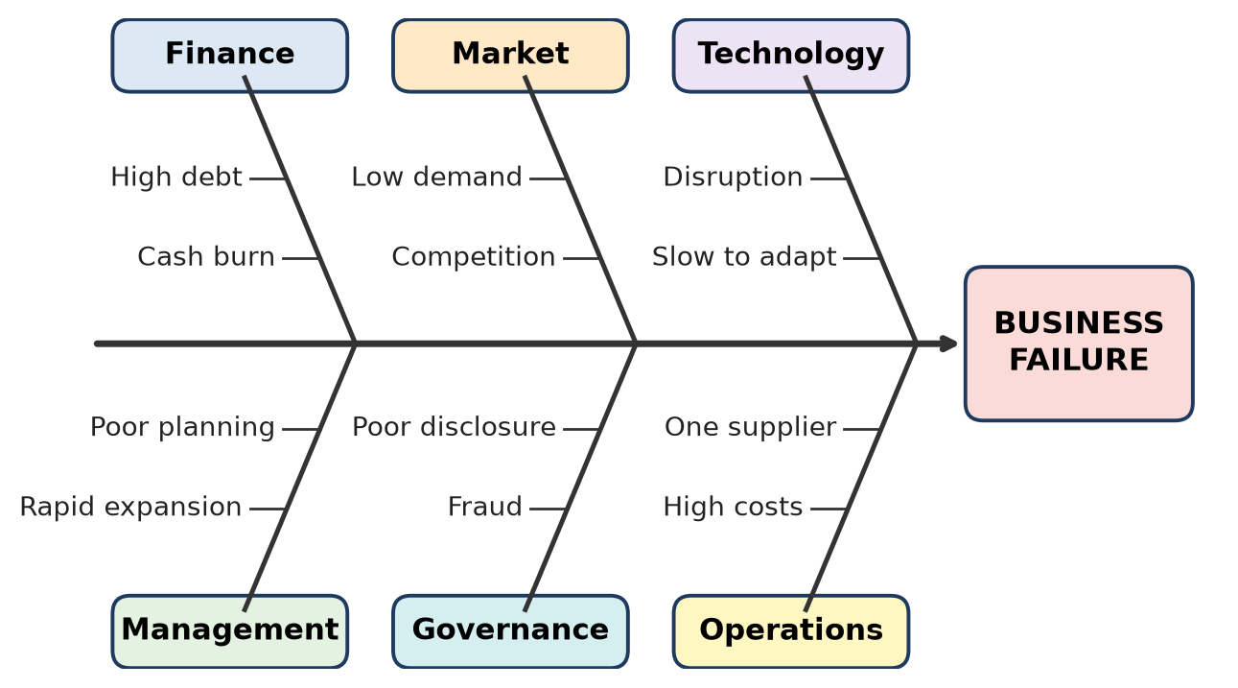
Figure: Reasons for business failure
Analysis: Failures usually have one main cause and supporting causes; financial weakness often turns another problem into a collapse.
Remember: Money, Machines (tech), Mad growth, Market shift, Morals (governance) – five Ms of failure.

Q12. A new venture plans to enter a market dominated by rapidly changing technology. Based on the experience of Nokia, examine the component of the business plan that should receive particular attention and explain its relevance.
5 Marks • L3 Apply • CO4
Component needing most attention: the technology and market (environment) analysis, with the product / R&D strategy that follows from it.
Nokia's lesson: Nokia led the market but misread the shift to touch-screen smartphones and app ecosystems; its plan focused on hardware and its own Symbian system.
What this section must include:
1. Technology trend analysis – which technologies are rising (AI, 5G, new operating systems).
2. Competitor analysis – new entrants, not just current rivals.
3. Customer analysis – what users value (apps, user experience, price).
4. SWOT and scenario planning – "What if the dominant technology changes?"
5. R&D and product roadmap – regular upgrades, flexible design.
6. Partnership strategy – with platform owners and developers.
7. Review mechanism – update the plan every few months.
Relevance:
Without it | With it
Product becomes outdated | Product evolves with technology
Late reaction to competitors | Early warning of disruption
Investors lose confidence | Plan shows adaptability

Remember: In fast tech markets, the business plan must watch the horizon, not the mirror.

Q13. Jet Airways, Stayzilla, Cafe Coffee Day, Reliance Communications, DHFL, Videocon Industries, Future Retail, Subhiksha. For each selected business, examine one "red flag" that a new entrepreneur should monitor in a similar venture.
5 Marks • L3 Apply • CO4
Business | Red flag to monitor
Jet Airways | Rising debt and delayed payments to lessors, vendors and staff in a high-fixed-cost business
Stayzilla | High cash burn without a clear path to profit while facing bigger, better-funded rivals; shut in 2017
Café Coffee Day | Group-level heavy borrowing to fund expansion and other businesses
Reliance Communications | Huge debt in a capital-intensive industry when a price war began (after Jio's entry in 2016)
DHFL | Asset–liability mismatch (short-term borrowing for long-term loans) and alleged fund diversion
Videocon Industries | Debt-funded diversification into unrelated sectors (oil and gas, telecom)
Future Retail | Aggressive debt-funded expansion and promoter share pledging; collapsed after COVID-19 and a failed rescue deal
Subhiksha | Too-rapid store expansion on thin margins; collapsed when funding dried up (2008–09)

Common red flags: rising debt, negative cash flow, delayed payments, unrelated diversification, poor transparency.
Remember: Watch the 3 Ds: Debt, Delays, Diversification.

Q14. Entrepreneur A has rapidly increasing sales and a growing customer base, but relies heavily on borrowed funds and operates with very low profit margins. Entrepreneur B has moderate sales growth and healthy profit margins, but is losing customers to a new technology introduced by competitors. Predict which entrepreneur is facing the more immediate risk of business failure and illustrate your choice using a suitable real-life business failure case.
7 Marks • L3 Apply • CO4
Prediction: Entrepreneur A faces the more immediate risk.
Reasoning:
1. Sales are not cash – with very low margins, more sales bring little profit; growth itself needs more working capital.
2. Heavy borrowing means fixed interest and repayment dates – one bad month can cause default.
3. No buffer – a small rise in cost or fall in price wipes out profit.
4. Lenders may stop credit suddenly → liquidity crisis → collapse within months.
Entrepreneur B: healthy margins give cash and time to respond (invest in new technology, partner, pivot). The risk is serious but slower – a medium-term threat.
Real-life case for A – Kingfisher Airlines / Jet Airways:
- Both had large customer bases and high passenger numbers.
- Margins were thin or negative; operations were funded by heavy debt.
- When cash ran out, salaries and dues were delayed and operations stopped (Kingfisher 2012, Jet 2019) – sudden collapse despite strong demand.
Case for B – Nokia: profitable at first, but lost customers to smartphones over several years.
Basis | A | B
Main risk | Liquidity / debt | Technological obsolescence
Speed of failure | Fast (months) | Slower (years)
Example | Kingfisher, Jet | Nokia, Kodak

Conclusion: Cash shortage kills faster than competition – A must cut debt and improve margins immediately.
Remember: Revenue is vanity, profit is sanity, cash is reality.

Q15. A food-delivery startup reports the following: customer numbers are increasing, delivery costs are rising, discounts are increasing, cash losses are growing, competitors are offering lower delivery charges. Determine the two most significant reasons that could lead this venture toward failure and suggest one modification to its business strategy.
7 Marks • L3 Apply • CO4
Two most significant reasons:
1. Negative unit economics (loss on every order)
- Rising delivery cost + rising discounts > earning per order (commission + delivery fee).
- More customers = bigger losses, so growth speeds up cash burn.
- Example of formula: Contribution per order = Commission + Delivery fee − Delivery cost − Discount; if this is negative, scaling is dangerous.
2. Intense price competition (no competitive advantage)
- Competitors charge less for delivery, so the startup feels forced to give more discounts.
- Customers are price-loyal, not brand-loyal; they leave when discounts stop.
- A price war usually favours the competitor with the deepest pockets.
Result: growing cash losses → dependence on fresh funding → if funding stops, closure (as with grocery-delivery startups like PepperTap, 2016).
Modification – shift from discount-led growth to profitable, differentiated growth:
1. Cut blanket discounts; use targeted offers and a paid loyalty subscription.
2. Raise order value – minimum order, combo meals, add groceries.
3. Lower delivery cost – cluster orders, batch deliveries, limited delivery radius, cloud kitchens near demand areas.
4. Differentiate – faster delivery, healthy-food niche, exclusive restaurant partners.
5. Track contribution margin per order weekly.
Remember: Fix the unit (each order) before you scale the units.

Topic 3: Essentials to Avoid Failure in Entrepreneurship

Q16. A new café chain plans rapid expansion after receiving investment. Illustrate one precaution from the Café Coffee Day experience that should be incorporated before opening multiple outlets.
3 Marks • L3 Apply • CO4
CCD background: Café Coffee Day (first café in Bengaluru, 1996) grew into India's largest café chain, but its parent company built up very heavy debt (also used for other businesses); after the founder's death in 2019 it had to sell assets and close many outlets.
Precaution: expand only with controlled debt and proven outlet-level profitability.
1. Check that each existing outlet is profitable before opening new ones.
2. Fund expansion mainly with equity and internal cash, not short-term loans.
3. Keep business finances separate from other ventures.
4. Open in phases; close weak outlets quickly.
Remember: One profitable café before a hundred cafés.

Q17. An engineering startup has limited funds and is considering spending most of its capital on office infrastructure before acquiring its first customers. Explain one alternative use of resources that would help reduce the risk of early-stage business failure.
4 Marks • L2 Understand • CO4
Problem: A fancy office is a fixed cost that brings no customers or revenue; spending most capital on it leaves no money for the product and runway.
Alternative: spend on building a Minimum Viable Product (MVP) and acquiring the first paying customers.
1. Customer validation – meet target customers, confirm the need and the price they will pay.
2. MVP / prototype – build a basic working product and test it with pilot customers.
3. Early sales and marketing – demos, trade fairs, digital marketing to win first orders.
4. Keep a cash reserve – working capital for 6–12 months.
5. Low-cost workspace – college incubator, co-working space or a home office.
Benefit: revenue and feedback arrive early; investors prefer startups with traction, not offices.
Remember: Customers first, cabins later.

Q18. An entrepreneur has limited funds and is planning to launch a new product. The following activities are proposed: A. Large office setup; B. Customer validation; C. Market assessment; D. Large-scale production. Arrange the activities in an appropriate sequence for reducing the risk of early business failure.
5 Marks • L2 Understand • CO4
Sequence: C → B → D → A
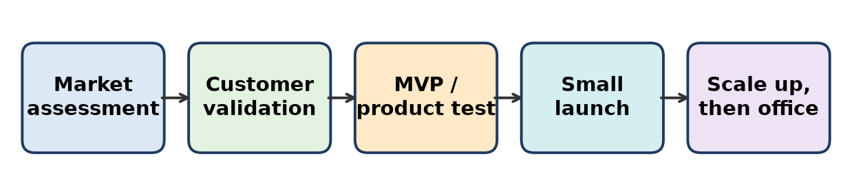
Figure: Low-risk launch sequence
1. C. Market assessment – study market size, competitors, customer segments and pricing. Is there a market?
2. B. Customer validation – test the idea or prototype with real customers; take pre-orders. Will they buy at this price?
3. D. Large-scale production – only after demand is proven; start with small batches and scale up.
4. A. Large office setup – last (or postpone), when revenue supports it; use low-cost space until then.
Why this order: money is spent step by step as risk reduces; the costliest, least useful items come last.
Remember: Check market → check customer → make → then the office.

Q19. Associate each entrepreneurial risk with the most appropriate preventive measure: Excessive borrowing; Uncertain customer demand; Rapid technological change; Dependence on one supplier.
5 Marks • L3 Apply • CO4
Entrepreneurial risk | Preventive measure | Example lesson
Excessive borrowing | Keep debt within limits; use equity, maintain cash reserves, monitor debt-to-equity and cash flow | Kingfisher, Jet Airways
Uncertain customer demand | Market research, customer validation, MVP / pilot launch, pre-orders | Quibi
Rapid technological change | Technology scanning, R&D, flexible product roadmap, partnerships | Nokia, Kodak
Dependence on one supplier | Multiple suppliers, long-term contracts, safety stock | Supply disruptions during COVID-19

Analysis: Each risk is reduced by planning before acting – finance planning, market testing, technology watch and supply-chain diversification.
Remember: Borrow less, test more, watch tech, never one supplier.

Q20. A startup has received ₹50 lakh in funding. It has only 500 paying customers and has not yet established a sustainable revenue model. The founder proposes: A. Expand to five cities; B. Increase office infrastructure; C. Validate the business model and strengthen customer acquisition; D. Launch three additional products. Select the most appropriate decision and illustrate the reason.
5 Marks • L3 Apply • CO4
Answer: C – Validate the business model and strengthen customer acquisition.
Reasons:
1. No proven revenue model – expanding an unproven model multiplies losses (A).
2. 500 customers is early traction – first find out why they pay, what it costs to acquire and keep each one.
3. Office spending (B) adds fixed cost without revenue.
4. More products (D) split focus and cash before the first product works.
What C involves:
- Measure Customer Acquisition Cost (CAC) and Lifetime Value (LTV); aim for LTV clearly above CAC.
- Improve retention and pricing; find the best sales channel.
- Reach break-even in the first city, then expand.
Example: Many startups (e.g. Subhiksha, PepperTap) failed by scaling before the model was profitable.
Remember: Prove it in one city before you copy it in five.

Q21. Byju's underwent rapid expansion before facing significant financial and governance difficulties. A new ed-tech entrepreneur plans a similar expansion strategy. Show any three checks that should be completed before implementing the expansion.
5 Marks • L3 Apply • CO4
Three checks before expansion:
1. Financial sustainability check
- Is the core business cash-flow positive or close to it?
- Is expansion funded by equity / profits rather than heavy debt?
- Does each acquisition have a clear payback plan?
2. Governance and compliance check
- Audited accounts filed on time; independent directors and an audit committee in place.
- Transparent reporting to investors and lenders.
3. Market and customer check
- Is demand lasting (not a one-time COVID-like spike)?
- Are customers satisfied – low refund requests and complaints, ethical sales practices?
- Can the team and systems handle growth (integration capacity)?
Check | Byju's issue it would prevent
Finance | Large debt and cash crunch
Governance | Delayed audits, board and auditor exits
Market | Demand fall after schools reopened

Remember: Before expanding, check the 3 Ms: Money, Management (governance), Market.

Q22. An entrepreneur has ₹10 lakh available for a new venture. The proposed allocation is: ₹7 lakh – office/interior setup; ₹1 lakh – market research; ₹1 lakh – product testing; ₹1 lakh – working capital. Determine the allocation that creates the greatest risk to the venture and modify the allocation principle to improve business sustainability.
7 Marks • L3 Apply • CO4
Greatest risk: ₹7 lakh (70%) on office / interior setup.
Why:
1. It is a sunk, non-productive cost – it does not create customers or revenue.
2. Only ₹1 lakh working capital – the business may run out of cash in a few months (salaries, rent, raw material).
3. Only ₹1 lakh each for market research and product testing – high risk of making a product nobody buys.
Modified principle: "Spend on validation and runway first, comfort last."
Item | Original (₹ lakh) | Modified (₹ lakh) | Reason
Office / interior | 7 | 1 | Co-working or incubator space
Market research | 1 | 2 | Understand customers and competition
Product testing / MVP | 1 | 2.5 | Make sure the product works and sells
Working capital and cash reserve | 1 | 4.5 | 6+ months of runway, emergency buffer
Total | 10 | 10

Principles:
- Keep fixed costs low, variable costs flexible.
- Keep a cash runway of at least 6 months.
- Release money in stages as milestones are met (customers, revenue).
Conclusion: Moving money from office to customers, product and cash greatly improves the chance of survival.
Remember: 70% on interiors = 70% chance of trouble; put cash where customers are.

Q23. A startup has: strong customer demand, limited cash reserves, increasing production costs, dependence on a single supplier, plans for rapid expansion. Model a three-point action plan that addresses the major risks before the entrepreneur proceeds with expansion.
7 Marks • L3 Apply • CO4
Situation: Demand is good, but cash, cost and supply risks can break the business if it expands now.
Three-point action plan:
1. Strengthen cash position (finance risk)
- Build a cash reserve of at least 3–6 months of expenses.
- Collect advance payments / faster receivables; negotiate longer supplier credit.
- Raise equity (not short-term debt) for expansion; prepare a monthly cash-flow forecast.
2. Control production costs (margin risk)
- Review pricing – pass on part of the cost rise; demand is strong.
- Value engineering, bulk buying, process improvement, reduce wastage.
- Track contribution margin per unit; expand only if it stays healthy.
3. Diversify suppliers (supply-chain risk)
- Qualify at least two more suppliers; sign supply contracts.
- Keep safety stock of critical parts.
- Consider in-house production of critical items later.
Then – phased expansion: expand to one new market at a time, with clear milestones (cash, margin, supply ready).
Risk | Action | Indicator to watch
Low cash | Reserve + equity | Months of runway
Rising cost | Pricing + cost cutting | Margin per unit
One supplier | Multiple suppliers | Supplier share < 50%

Remember: Fix Cash, Cost and Supply (3 Cs) before you Conquer new markets.

Topic 4: Case Study of Failure in Entrepreneurship

Q24. Kingfisher Airlines and Nokia experienced very different forms of business decline. Kingfisher faced serious financial and operational difficulties. Nokia struggled during major changes in the mobile-phone industry. Associate each case with one precaution that would be particularly relevant to a new entrepreneur entering the respective industry.
3 Marks • L2 Understand • CO4
Case | Type of decline | Precaution for a new entrepreneur
Kingfisher Airlines (airline industry) | Financial and operational | Financial discipline – low debt, cash reserves, cost control, avoid costly acquisitions in a high-fixed-cost industry
Nokia (mobile-phone industry) | Technological / market change | Continuous innovation and technology tracking – adapt fast to new platforms and customer preferences

Remember: Airline: watch the cash; Mobile: watch the technology.

Q25. A startup similar to Stayzilla is experiencing falling revenue. Model a three-step decision path beginning with: Falling revenue → ______ → ______ → ______. The final step should represent the entrepreneur's decision after examining the situation.
4 Marks • L3 Apply • CO4
Decision path:
Falling revenue → Diagnose the cause → Evaluate options → Decide (fix, pivot or exit)
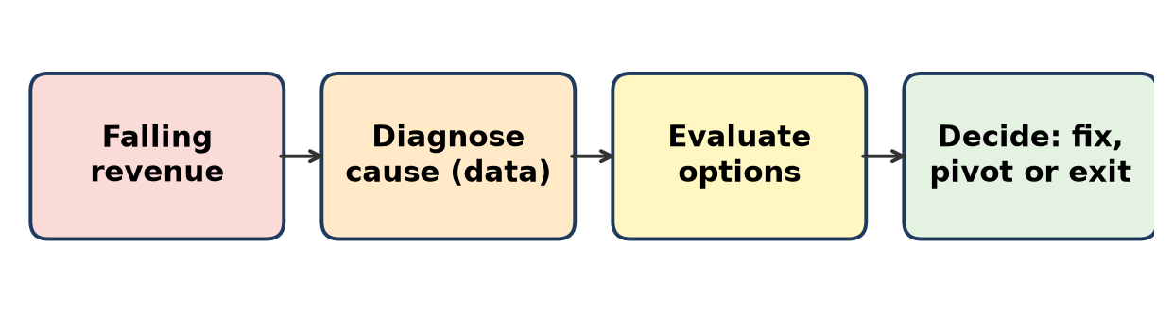
Figure: Decision path for falling revenue
1. Diagnose the cause (with data) – fewer bookings? lower price per booking? competition (larger platforms)? poor customer experience? high customer-acquisition cost?
2. Evaluate options –
- cut cash burn (marketing, staff, offices);
- focus on profitable cities or segments (e.g. homestays);
- partner, merge or raise funds;
- change the revenue model.
3. Decision – choose one: fix (cost cuts + focus), pivot (new segment / model), or exit responsibly (sell or close while paying dues).
Stayzilla, a Chennai-based homestay platform, shut down in 2017 amid heavy cash burn and strong competition – a timely, data-based decision path is the lesson.
Remember: Falling revenue: Diagnose → Options → Decide.

Q26. Compare the following: Kodak – major technological/market transition; Kingfisher Airlines – financial and operational difficulties. Complete the table (Case | Dominant risk | Preventive focus).
4 Marks • L2 Understand • CO4
Case | Dominant risk | Preventive focus
Kodak | Technological disruption – shift from film to digital photography (Kodak itself invented the first digital camera in 1975 but protected its film business; filed for bankruptcy in 2012) | Innovation and adaptability – embrace new technology even if it replaces the existing product; R&D, market tracking
Kingfisher Airlines | Financial risk – heavy debt, continuous losses, unpaid dues leading to operational collapse (2012) | Financial discipline – cost control, limited debt, cash-flow monitoring, careful acquisitions

Comparison: Kodak failed by not changing; Kingfisher failed by spending and borrowing beyond its means.
Remember: Kodak = ignored the future; Kingfisher = mortgaged the future.

Q27. Quibi launched in April 2020 and shut down roughly six months later. Product development → __________ → Market launch → Customer response → Business decision. Determine the entrepreneurial activity that should occur between product development and large-scale launch.
5 Marks • L3 Apply • CO4
Missing activity: Market testing / customer validation (pilot or MVP launch).
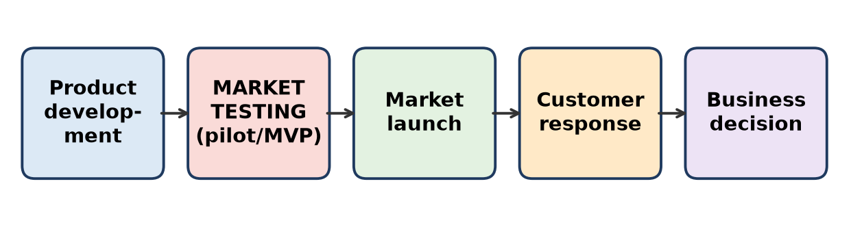
Figure: Where market testing fits
Quibi background: a US short-video streaming service for phones, founded by Jeffrey Katzenberg and Meg Whitman; raised over a billion dollars, launched in April 2020 and announced shutdown in October 2020 because too few users subscribed.
Why market testing was needed:
1. Check real demand – would people pay for short shows only on phones?
2. Test features – early users could not easily watch on TV or share clips; testing would have shown this.
3. Test pricing – compare free vs paid models.
4. Check timing – during COVID lockdowns people were at home on big screens, not commuting.
5. Lower cost of learning – fix problems before spending heavily on a big launch.
How to do it: beta launch in a small market, free trial with feedback, A/B tests, measure retention.
Remember: Test small, learn fast, then launch big.

Q28. About Satyam Computer Services, a student writes: "The Satyam case mainly demonstrates the importance of increasing advertising expenditure during rapid business growth." Identify the conceptual error and modify it with the appropriate entrepreneurial lesson.
5 Marks • L3 Apply • CO4
Conceptual error: Satyam did not fail because of low advertising. It failed because of accounting fraud and a failure of corporate governance.
Facts: In January 2009, chairman B. Ramalinga Raju confessed that the company's accounts had been falsified for years – profits and cash balances were inflated by thousands of crores. The government replaced the board, and the company was later taken over by the Mahindra group (Tech Mahindra).
Corrected statement: "The Satyam case mainly demonstrates the importance of ethics, transparent financial reporting and strong corporate governance during rapid business growth."
Lessons:
1. Integrity – never manipulate accounts to show growth.
2. Independent board and audit committee – must question management.
3. Strong internal controls and honest external audit.
4. Transparency builds long-term trust of investors, clients and employees.
5. Pressure to show growth must not override honesty.
Remember: Satyam (truth) was lost through false accounts – governance, not advertising.

Q29. A startup has experienced the following sequence: Rapid expansion → increasing expenditure → cash-flow pressure → delayed payments → loss of stakeholder confidence. Illustrate a real failed business case that demonstrates a similar pattern and construct two points in the entrepreneur's earlier decision-making where corrective action could have been introduced.
5 Marks • L3 Apply • CO4
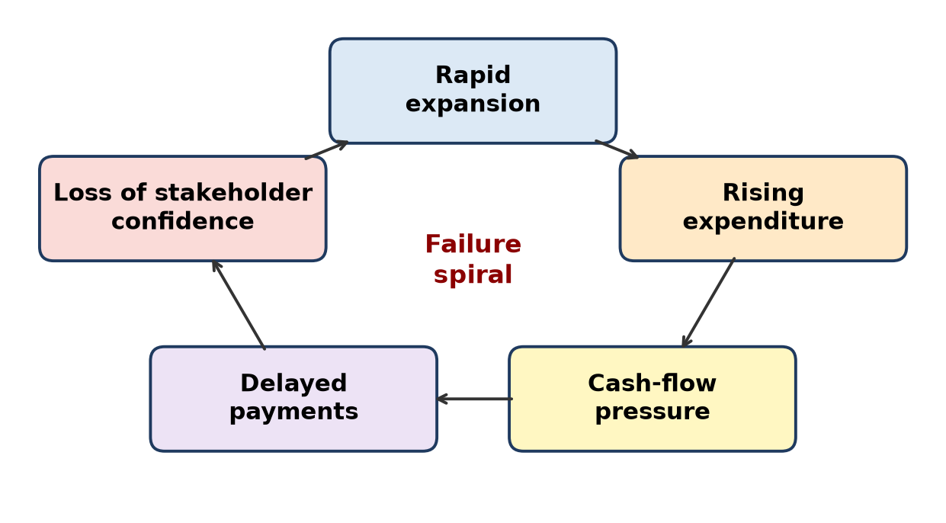
Figure: The failure spiral
Real case: Kingfisher Airlines
1. Rapid expansion – fast fleet growth and the takeover of Air Deccan (2007).
2. Increasing expenditure – luxury service, more aircraft leases, high fuel costs.
3. Cash-flow pressure – continuous losses, rising bank debt.
4. Delayed payments – salaries unpaid for months; dues to oil companies and airports.
5. Loss of stakeholder confidence – staff strikes, lenders and regulator acted; licence suspended in October 2012.
Two points for corrective action:
Decision point | Corrective action
1. Before the Air Deccan acquisition / fleet expansion | Do due diligence, test whether a premium airline could also run a low-cost brand profitably; expand only with equity, not debt
2. When losses and debt first rose (early cash pressure) | Cut capacity and costs early, renegotiate leases, raise fresh equity, sell non-core assets – before salaries were delayed

Lesson: The spiral can be broken early; once payments are delayed, trust collapses fast.
Remember: Break the spiral at the first turn – before the first delayed salary.

Q30. Consider the following cases: Kodak – difficulty adapting to digital photography; Kingfisher Airlines – severe financial difficulties; Nokia – challenges responding to technological and market changes. Model one common pre-launch checklist containing three checks that an entrepreneur can use to reduce the risk of experiencing similar failure conditions.
7 Marks • L3 Apply • CO4
Common pre-launch checklist:
No. | Check | Key questions | Case it guards against
1 | Technology and market adaptability check | What technologies could replace my product in 3–5 years? Do I have an R&D and update plan? Am I tracking customer trends? | Kodak, Nokia
2 | Financial sustainability check | Is each unit / sale profitable? Is debt within safe limits? Do I have 6+ months of cash runway? Is a cash-flow forecast ready? | Kingfisher
3 | Customer validation and flexibility check | Have real customers tested and paid for the product? Can the business model pivot if demand shifts? | All three

How to use it:
1. Score each check (Green / Amber / Red) before launch and before every major expansion.
2. Do not launch or expand while any check is Red.
3. Review the checklist every quarter – risks change.
Explanation:
- Kodak and Nokia show that ignoring technology change can sink even market leaders.
- Kingfisher shows that weak finances can sink a popular brand.
- Customer validation links both: it reveals changing needs early and shows whether revenue can cover costs.
Conclusion: A simple Tech – Money – Customer checklist can prevent the most common causes of failure.
Remember: Pre-launch "TMC": Technology ready, Money safe, Customer proven.

Quick Revision – Unit 4
Term / Case | Key fact
Entrepreneurial failure | Venture cannot meet its goals or survive financially and has to close
Product–market fit | Product solves a problem customers will pay for
Unit economics | Profit or loss on each unit / order; must be positive before scaling
Kingfisher Airlines | Launched 2005; heavy debt, losses, unpaid salaries; ceased October 2012
Jet Airways | High debt and fixed cost, low-cost competition; suspended April 2019
Nokia | Late to smartphones (iOS, Android); phone business sold to Microsoft 2014
Kodak | Invented digital camera 1975 but clung to film; bankruptcy 2012
Blockbuster | Disrupted by Netflix and streaming; bankruptcy 2010
Byju's | Rapid debt-funded expansion and acquisitions, governance lapses; insolvency proceedings 2024
Satyam | 2009 accounting fraud – lesson: corporate governance and ethics
Quibi | Launched April 2020, shut about 6 months later – no market testing
PepperTap | Hyperlocal grocery; poor unit economics; shut April 2016
Café Coffee Day | Debt-funded expansion; precaution: profitable outlets, controlled debt
Low-risk launch order | Market assessment → Customer validation → Production → Office
Failure spiral | Rapid expansion → expenditure → cash pressure → delayed payments → lost confidence
Pre-launch checklist | Technology adaptability, financial sustainability, customer validation

